**Quality**

**Layer height**

The layer height is one of the most frequently changed settings. It is the thickness of one printed layer in millimeters. With a thinner layer height, you can increase the quality of the print, leading to a smoother surface and more detail visible in the Z-direction (height) of the model. On the other hand, by using thicker layers you can decrease the print time substantially.

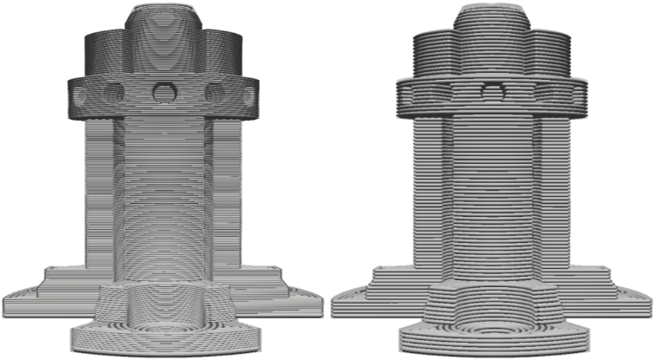The model on the left has a bigger layer height than the model on the right.

The recommended mode allows the user to easily choose a layer height compatible with the current print core and material configuration. The number of available layer heights options differ per configuration. The custom mode allows the user to completely customize the layer height.

**Note: In the custom mode, choose a layer height close to your desired custom layer height. The profile contains layer height dependent settings, like temperatures, to ensure a high-quality print.**

**Initial layer height**

This setting defines the height of the first layer of your print. The initial layer height is usually thicker than the layer height to create a stronger adhesion with the build plate. When the model has a lot of detail on the first layer, it might have a decreased quality because of the thicker layer. This limitation can be compensated for with the "initial layer horizontal expansion" setting, which is found under the Shell category.

**Line width**

Line width defines the width of a single printed line, which should be close to the nozzle size. Based on the line width, the extrusion rate is adjusted, which means that it will automatically calculate how much material must be extruded.

***Example 1:*** *Decrease the line width slightly of the outer wall to allow sharper detail on the model.*

***Example 2:*** *An increased line width of the infill allows the infill to print slightly faster.*

***Tip:*** *If you use an unavailable third-party nozzle size, set the line width to equal the nozzle size.*

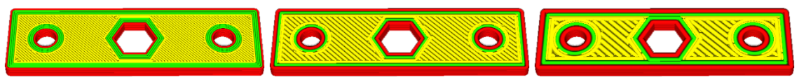The exact same model with line widths of 0.25, 0.4 and 0.8 nozzles.

The line width can be set individually for all line types available:

* **Wall line width:** The width of a single wall line. The line width of the inner and outer walls can be adjusted separately.
* **Top surface skin line width:** This line width is only available when a top surface skin is used.
* **Top/bottom line width:** The line width with which the top and bottom layers are printed.
* **Infill line width:** The line width of all infill material.
* **Skirt/brim line width:** The width of the skirt or brim lines.
* **Support line width:** The line width of support structures.
* **Support interface line width:** The width of a single support interface line.
* **Prime tower line width:** The width of a single prime tower line.
* **Initial line width:** The width of lines on the initial layer.

**Shell**

**Wall extruder**

This setting defines which extruder should print the walls. It can be set for the inner or outer wall separately.

*Example: Use two colors of the same material to create outlines on 3D prints.*

**Wall thickness and wall line count**

This setting adjusts the thickness of walls of the model. Ultimaker Cura rounds the wall thickness to a multiplication of the line width. In general, a wall thickness of two or three times the line width is sufficient. A higher value will create a sturdier model and decreases the chance of leaks, while a lower value can significantly decrease the print time and filament costs.

Instead of setting a thickness in millimeter of the walls, you can also set a number of walls. When you set the wall line count, the wall thickness is calculated and will grey out.

*Example: A value of 1 mm, results in three walls of 0,35mm = 1,05mm wall. The model on the left has three walls, the model on the right has a single wall.*

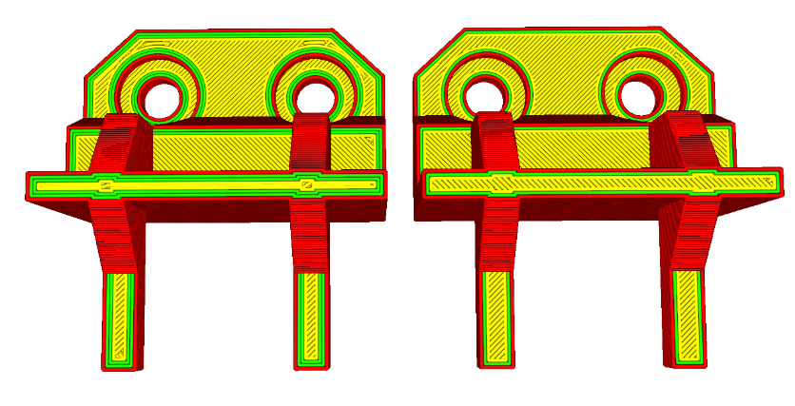

**Outer wall wipe distance**

At the end of every outer wall, a short path is traveled without extrusion. This results in a reduced seam when traveling from the outer wall to other parts of the 3D print. It is visible in the layer view by short travel moves right over the outer wall.

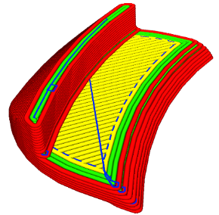

**Top surface skin**

Top surface skin is the top-most layer of skin, which can be adjusted separately. This allows one to print at higher quality which results in a better surface finish. It has the following settings to change:

**Top surface skin extruder**

The extruder can be set for the top surface skin layers. The second extruder may contain a different print core or material.

**Top surface skin layers**

This setting defines how many layers of all top skin layers will be affected by the setting. Two or three layers are often enough to have an improved surface quality.

**Top surface skin pattern and line directions**

The pattern can be set separately to get a different visual effect. If set to lines, the angle of the lines can also be set for more precise control.

**Top surface print speed**

The speed can be changed to enhance the print's surface quality. Print it at the same speed as the outer wall to get a smooth finish.

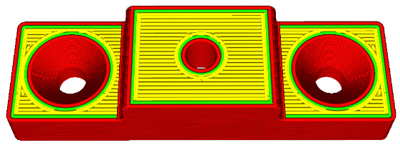

This model has a top surface skin pattern of horizontal lines.

**Top/bottom extruder**

This setting defines which extruder should print the top and bottom layers. Different colors or nozzle sizes can be used for the second extruder.

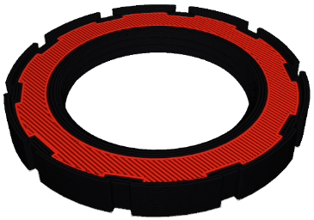

**Top/bottom thickness**

With the top/bottom thickness you can set the thickness of the solidly printed top and bottom layers of the print. A higher value ensures all gaps on the top and bottom layers are closed completely. However, this can also increase the print time and amount of filament used.

It is advised to always use a multiple of the layer height for the thickness of the top and bottom. This means, for example, that with a layer height of 0.15 mm, it’s better to set the top/bottom thickness to 0.6 mm rather than 0.7 mm.

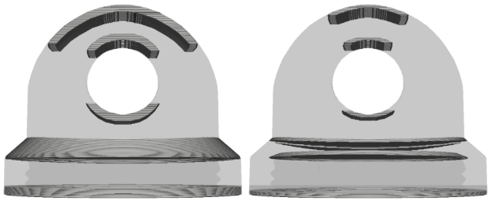

The model on the left has a top/bottom thickness of 1.4mm, the one on the right is just 0.7mm.

**Separate top or bottom thickness**  
You can also set the thickness of the top and bottom layers separately. This is especially useful for the top as you may need a few layers to close it properly and prevent “pillowing”. By using fewer layers for the bottom you can save material and print time.

**Number of top/bottom layers**  
Instead of setting a height in millimeters for the top or bottom layers, you can set a specific number of layers. The resulting height in millimeters will be calculated automatically depending on the layer height set. *Example: Number of top layers 12 * 0.1mm layer height = 1.2mm top layer thickness.*

**Top/bottom pattern**

Ultimaker Cura allows you to choose from different printing patterns for the top and bottom layers. These are the available patterns:

* Concentric: The pattern is printed from the outside to the center of the print.
* Lines: A diagonally printed pattern with travel moves on the shell of the model.
* Zig-zag: A diagonally printed pattern with connections on the shell of the model.

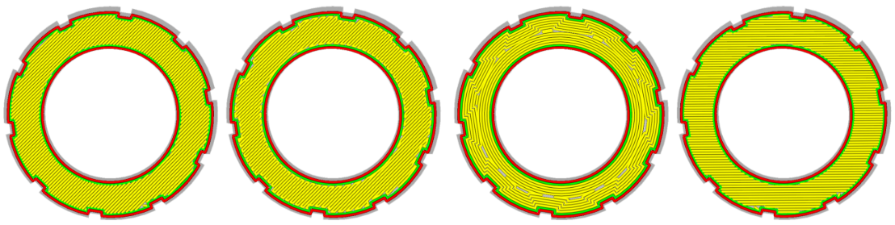Lines, zig zag, concentric and 'line direction' with custom value [90]

**Bottom pattern initial layer**

This refers to the pattern of the layer that is printed directly onto the build plate. It can be changed separately. Use this feature to get models with specific bottom visuals.

**Top/bottom line direction**

This setting allows you to change the direction in which the top and bottom skin lines are printed. Normally, they print in a diagonal direction. This is the fastest and uses both the X- and Y-motors. Changing the direction can have a visual effect. Multiple numbers can be entered to change the line direction each layer, for example: [90,0] this creates a horizontal-vertical direction.

**Outer wall inset**

This setting compensates the position for the outer wall, if the line width chosen is smaller than the nozzle. For example: A line width of 0.35 with a 0.40mm nozzle leaves a gap of 0.05mm on both sides of the actual printed line. A compensation of 0.025 is set to compensate for the outermost part.

**Outer before inner walls**

This setting determines which walls are printed first, the outer or the inner walls. When enabled, the outer walls are printed first and X-Y dimensions are more exact. The downside is that overhang quality is decreased.

**Alternate extra wall**

This setting adds an extra wall every other layer. This way the infill gets caught between the walls, resulting in stronger prints. For example, if you set the wall line count to two walls and enable alternate extra wall, it will print two walls on even numbered layers and three walls on odd numbered layers.

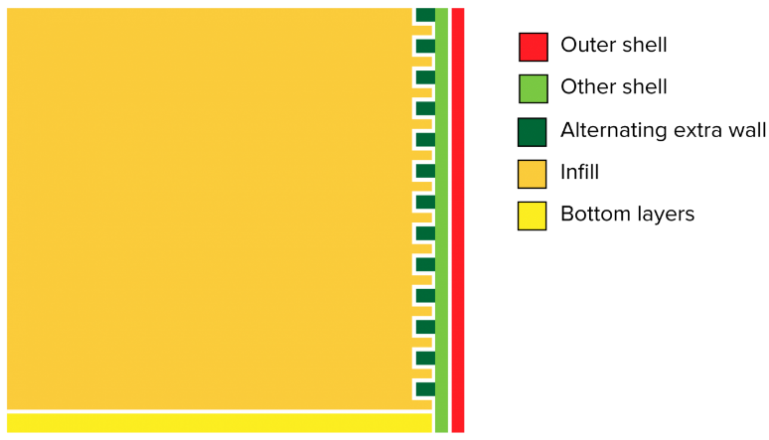

**Compensate wall overlaps**

With this setting the extrusion on printed parts is reduced where the print head has to go over a thin area twice. This way all walls are printed without the part being over extruded. The setting can be enabled for the outer or the inner walls separately.

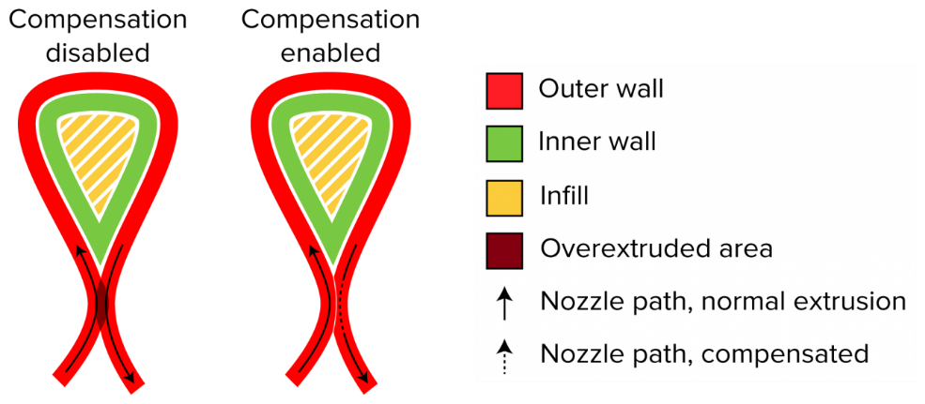

**Fill gaps between walls**

For fine details, the printer might need to print areas that are thinner than the nozzle size. This can happen between the outer and inner walls where the model ends in sharp corners. This option allows these gaps to be filled after printing both walls. The illustration shows a droplet which has to be printed.

*Note: See how the fill gaps option influences the travel moves. The printer has to come back to the gap at later times to fill it.*

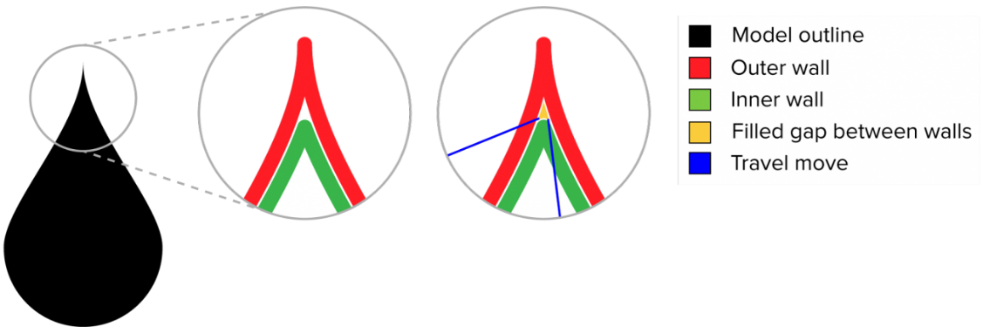

**Filter out tiny gaps**

Some gaps between walls are so small that the extra travel path is not worth the extra extrusion to compensate for it. Enable this feature to fill those minuscule gaps anyway, if needed.

**Print thin walls**

This setting allows walls to be printed that are thinner than the nozzle size. Since the nozzle cannot physically do this, the paths might still be over extruded if enabled, however, they will not be completely removed.

**Horizontal expansion**

Horizontal expansion be beneficial if the tolerance of the print is important. Due to a slight deformation of plastics, the actual dimensions of the print may not completely correspond with the dimensions of the digital model. By adjusting the horizontal expansion value, you can compensate for this slight deviation. A higher value will increase the X/Y size of the model, while a negative value decreases the X/Y size.

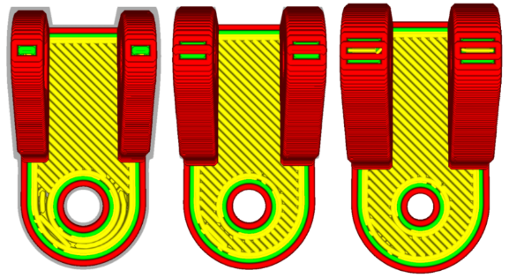

This model with a screw hole has been expanded -0.1mm, 0mm, +0.1mm

**Initial layer horizontal expansion**

This feature has the exact same effect as horizontal expansion, except that it is only applied to the layer printed on the build plate. This may help in overcoming over extrusion on the first layer, increasing the dimensional accuracy. A value of half the line width is advised.

**Z-seam alignment**

This setting allows you to choose where each new layer in the Z direction starts and affects where the seam of the model will be. This is useful for models with consecutive equal layers as the seam can be visible. By changing the Z-seam alignment you can decrease the visibility of the seam. The options available are:

* **User specified:** Set a coordinate for the X and Y direction of the Z-seam. This coordinate is absolute by default. Example: X 100, Y 200 will move the seam to the center back of the model.
* **Shortest:** The next layer starts at the endpoint of the previous layer. This is the fastest way of printing, but also creates the most visible seam.
* **Random:** The next layer starts at a random point of the previous layer, which eliminates the chance of a seam. Print time will increase due to the necessary travel moves.
* **Sharpest corner:** This puts the seam in the sharpest inward or outward corner of the model, when available. This is the best method to completely hide the seam.

**Seam corner preference**

The Z-seam is hidden as much as possible by default. However, for some projects, specifically those that require post-processing, exposing the seam can be necessary for the post-print processing. To do so, you can adjust the following settings:

* **None:** The seam will remain on the Z-seam alignment location.
* **Hide seam:** The seam will be hidden as much as possible.
* **Expose seam:** The seam will be exposed as much as possible.
* **Hide or expose:** The seam will be hidden when possible and exposed when there is no other option.

**Ignore small Z gaps**

Small gaps between the layers in the Z-direction of a model can be “fixed” by using this setting. Disabling it will ensure the layers will fuse together by printing infill between the bottom and top of the gap. If you disable this setting, it won’t fill the gap and will simply print the bottom and top as they appear in the model.

**Extra skin wall count**

By using this setting, the outermost part of the top/bottom pattern will be replaced by a number of concentric lines. Using one or two lines can improve roofs that start on infill material and ensure that they come out sturdier and with a smoother surface.

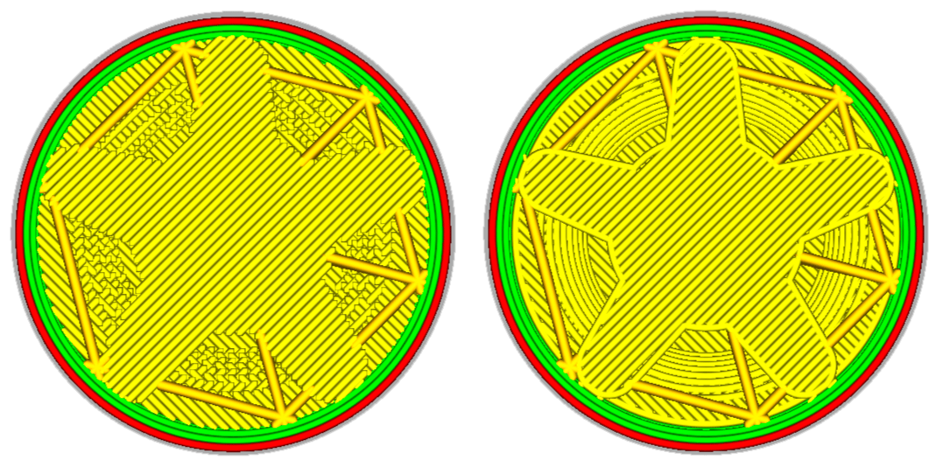

**Enable ironing**

Ironing is a technique where the nozzle travels over the top-most layer after printing it, to iron the top layers to a smooth surface. The settings for ironing can be adjusted to get the desired surface finish:

* **Only highest layer:** This setting will apply ironing only to the very last printed layer.
* **Pattern:** A pattern can be chosen to iron.
* **Line spacing:** Determines the space between every line.
* **Flow:** While ironing, this percentage of material is extruded on top of the last layer.
* **Inset:** Ironing is applied to an offset of the outer edge of the model in the X-Y direction.
* **Speed, acceleration, and jerk:** The speed of ironing can be adjusted to fine-tune the process.

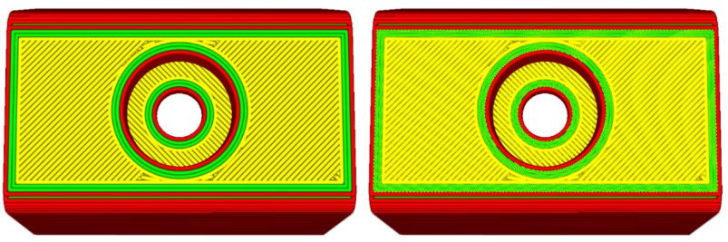

**Infill**

**Infill density**

The infill density defines the amount of plastic used on the inside of the print. A higher infill density means that there is more plastic on the inside of your print, leading to a stronger object. An infill density around 20% is used for models with a visual purpose, higher densities can be used for end-use parts.

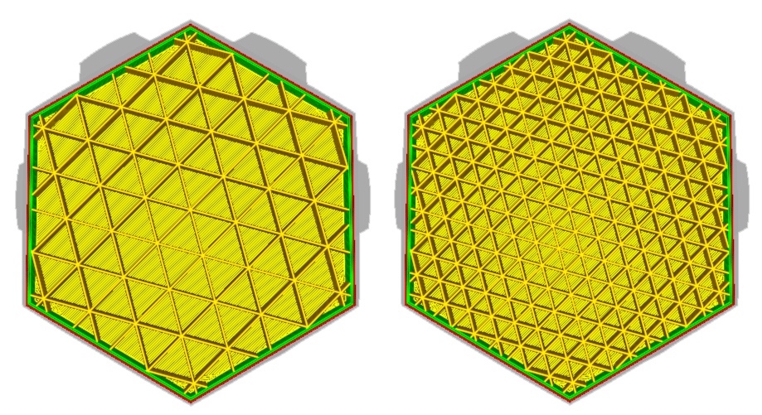

The model on the left has a higher infill density than the model on the right

**Infill line distance**

Instead of setting the infill density as a percentage, it’s also possible to set the line distance. This determines the distance between each infill line, which has the same effect as changing the infill density.

**Infill pattern**

Ultimaker Cura allows you to change the pattern of the printed infill structure, which is beneficial in some use cases. For example:

* **Strong 2D infills** are used for everyday prints
* **Quick 2D infills** are used for quick, but weak models
* **3D infills** are used to make the object equally strong in all directions
* **3D concentric infills** are used for flexible materials

The following pattern options are available:

* **Grid:** Strong 2D infill
* **Lines:** Quick 2D infill
* **Triangles:** Strong 2D infill
* **Tri-hexagon:** Strong 2D infill
* **Cubic:** Strong 3D infill
* **Cubic (subdivision):** Strong 3D infill (this saves material compared to Cubic)
* **Octet:** Strong 3D infill
* **Quarter cubic:** Strong 3D infill
* **Concentric:** Flexible 3D infill
* **Concentric 3D:** Flexible 3D infill
* **Zig-zag:** A grid shaped infill, printing continuously in one diagonal direction
* **Cross:** Flexible 3D infill
* **Cross 3D**: Flexible 3D infill

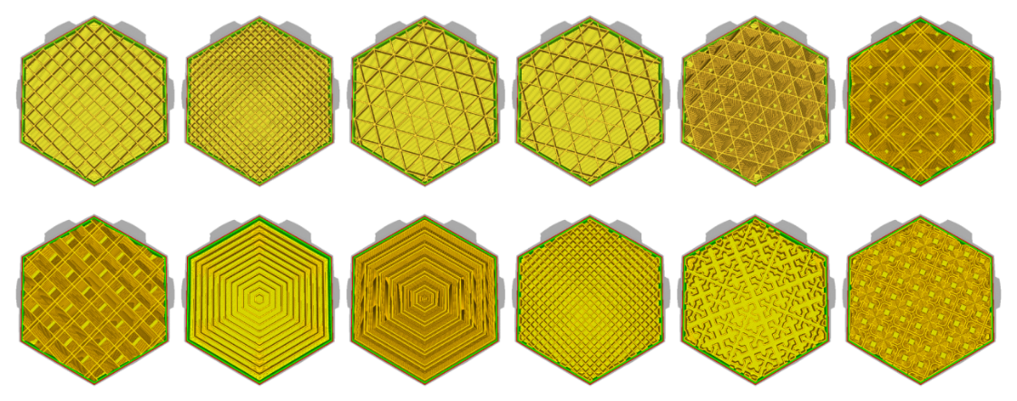The infill patterns are displayed in the order of the list above

**Infill line directions**

The infill lines usually print at a 45° angle. At this angle, both the X- and Y-motor work together to obtain maximum acceleration and jerk on the layer without losing quality. If the lines need to be printed in a different direction, you can set it here at 0° for vertical and 90° for horizontal. For example: [0,90] results in a horizontal-vertical top/bottom pattern.

**Infill XY offset**

Infill patterns are centered for each model loaded. To move the pattern to the left, right, top, or bottom a X or Y offset can be used. A positive value moves it UP and RIGHT, while a negative value moves it DOWN or LEFT. This does not work for the concentric infill types.

Infill overlap percentage

With this setting you can control the amount of overlap between the infill and walls. It can be set as a percentage or a true value. A higher value usually results in better bonding between the infill and walls. However, it might also reduce the visual quality of the print, as a value that is too high could lead to over extrusion. The default value in Ultimaker Cura will be sufficient in most cases.

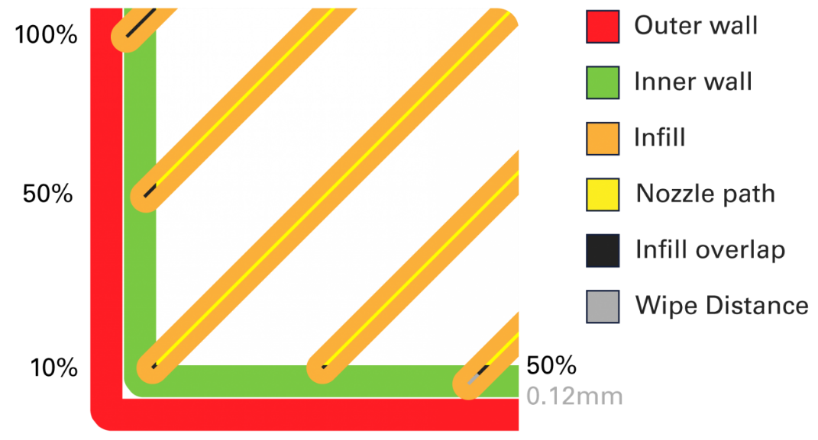

A visualization of the infill overlap and wipe distance

**Skin overlap (percentage)**

The skin overlap works in the same way as the infill overlap, which is described in detail above. It can be set as a percentage or a true value. The skin overlap influences all top and bottom layers in a print.

**Infill wipe distance**

This setting instructs the printer to stop extruding at the end of printing the infill before it starts printing the walls. The printer will still ooze a little bit of filament due to the pressure in the nozzle, but by stopping the extrusion early, you'll reduce over extrusion on the shell. See the image above.

**Infill layer thickness**

Since the layer height of the infill is not important for visual quality, you can use thicker layers on the infill to reduce the print time. When adjusting this setting, always make sure that it is a multiple of the layer height, otherwise Ultimaker Cura will round it up to a multiple of the layer height. This means that you can, for example, print with an infill thickness of 0.2 mm while the layer height is 0.1 mm. The printer will first print the walls for two layers, and then it will print one thicker infill layer.

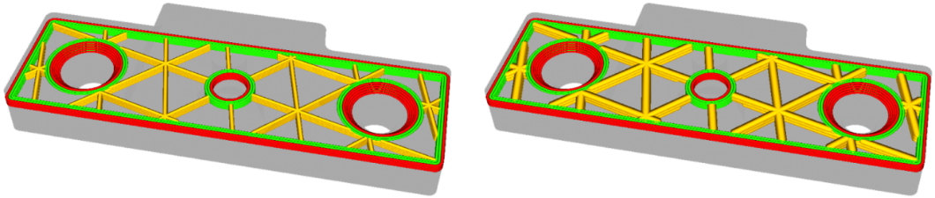

**Gradual infill steps**

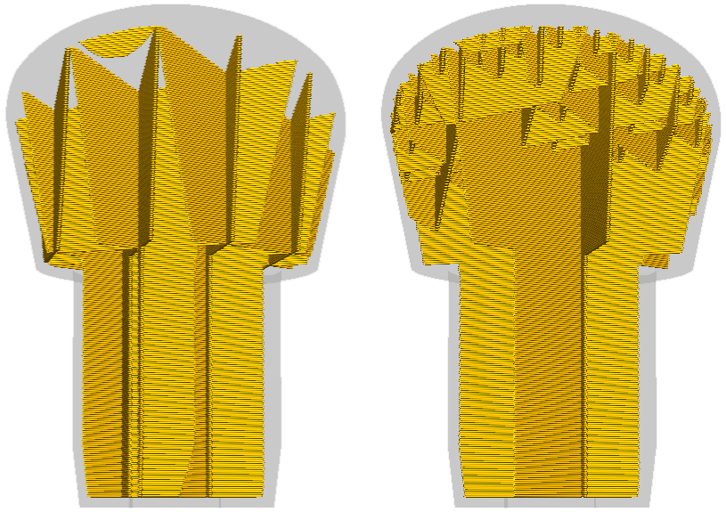Gradual infill reduces the amount of infill used by decreasing the infill percentage in the lower layers. Every gradual infill step divides the infill percentage by a factor two. The result is a dense infill near the top layers, which is essential, and a reduced print time.

Example: Gradual infill steps = 2 and infill = 20% --> Infill = 20% for the top 5mm, infill = 10% for the rest of the print

**Gradual infill step height**

Gradual infill step height is the height at which the infill should be reduced, as calculated from the top layers. This way the top layers can easily be closed, without the use of extra infill in the print.

**Infill before walls**

With this setting enabled, infill will be printed before the walls. This results in better overhangs because the walls will stick to the already printed infill. Printing in this order can also have a disadvantage. If the infill is printed before the walls, there is a chance that the infill will be visible through the walls, resulting in a rougher surface finish.

**Minimum infill area**

This setting allows small areas on a single layer to be printed with skin instead of infill. Take a flat roof with a chimney, for example, the chimney is thin and fragile and can be printed solidly with skin.

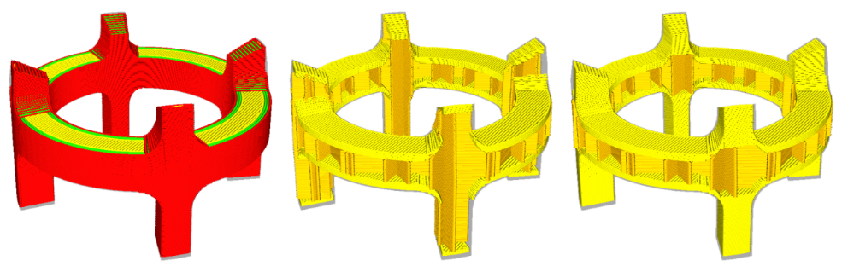

The minimum infill area strengthens the legs of this coupler by filling it completely with skin

**Skin removal and skin expansion**

The skin (top and bottom layers) in a model is printed to reach the minimum thickness set in the print profile. However, some models need a stronger or lighter internal geometry. These settings expand or remove the skin horizontally, where infill would normally be printed. Expanding this slightly allows protruding model elements to have better adhesion to the rest of the model, making it stronger or lighter. Flat surfaces with protruding elements in the Z-direction will have a stronger base, making it sturdier.

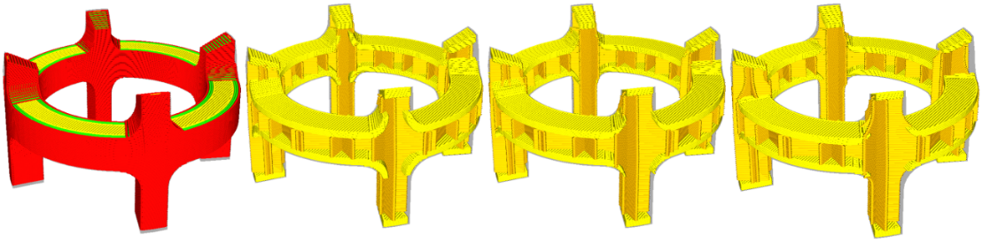From left to right; A preview of the model, skin expansion of 0.8mm, no skin expansion or removal, skin removal of 0.8mm

**Skin removal width**

This is the width of the skin to be removed when applying skin removal. It can be applied individually to the top and bottom layers.

**Skin expand distance**

This refers to the distance by which the skin will be expanded. A bigger value results in longer, but sturdier prints. A lower value will only marginally increase the strength.

**Maximum skin angle for expansion**

Since skin is present throughout the model, it is unnecessary to expand all of the areas. Rather, only the areas below the angle specified here will be expanded. In that way, flat surfaces with protruding elements will be strengthened, without affecting the rest of the model. For this, 0° is horizontal (and does not expand anything), while 90° is vertical, and expands everything.

**Minimum skin width for expansion**

This parameter will prevent small skin (top and bottom) areas from expanding. It is specifically used when targeting only the strength of large, flat surfaces of the model.

**Material**

**Default printing temperature**

This is the printing temperature of the materials as found in the materials panel, without any extrusion rate corrections applied to it.

**Printing temperature**

This refers to the temperature of the nozzle while printing, including the adapted extrusion rate. Each printing profile has a slightly different printing temperature to create the best print result.

**Printing temperature initial layer**

This is the printing temperature of the layer that adheres to the build plate. Printing at a slightly warmer temperature increases the adhesion between the build plate and the model.

**Initial printing temperature**

This setting is only used in dual extrusion machines. When switching nozzles, the inactive nozzle cools down to the standby temperature. During the warm up, the nozzle is allowed to start printing when this temperature is reached. The temperature is slightly lower than the printing temperature since the filament already obtained heat from the nozzle for a longer period of time.

**Final printing temperature**

This setting is only used in dual extrusion machines. When switching nozzles, the inactive nozzle has to cool down. Just before the nozzle switch, the nozzle is allowed to cool down to this temperature while continuing to extrude. This prevents excessive oozing when in standby mode.

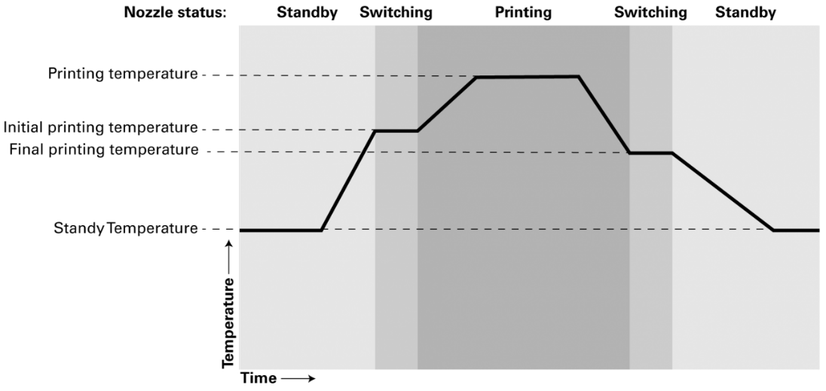

**Extrusion cool down speed modifier**

The temperature change here indicates how much faster the nozzle cools down when extruding. The extra heat lost by extruding hot filament is compensated by this value.

**Build plate temperature**

This setting defines the heated bed temperature during the printing process. Each material has an ideal build plate temperature, which is set here. When printing with two different materials, the temperature will be an average of the two. Changing this value is uncommon.

**Build plate temperature initial layer**

This is the temperature of the build plate when printing the first layer. A slightly warmer build plate during the layer reduces the chance of warping.

**Diameter**

This setting defines the diameter of the filament in order for Ultimaker Cura to calculate the extrusion rate correctly. All Ultimaker filaments have a diameter of 2.85 mm, but you might need to change this setting when using filament from other suppliers.

**Flow**

The flow is the amount of material that needs to be extruded over a specific amount of time and is based on the filament diameter and print speed. The flow is always set to 100%, which means that the extruded amount of filament will match the calculated amount. This setting is not usually changed, as the calculation is done automatically, but it can be useful when printing with experimental materials.

It is not advised to increase the flow to compensate for under extrusion. This will only work temporarily and won’t solve the underlying cause.

**Enable retraction**

Retraction is used at the places in a print where the printer has to do a travel move between two printed parts. Without retraction, extruded material will hang between the parts. By using retraction, “stringing” (thin threads of plastic in between the printed parts) is prevented, resulting in a much cleaner model. Exercise caution when using flexible materials or models that require a lot of retractions as it may lead to grinding of the filament.

**Retract at layer change**

This setting forces the printer to retract the filament before it starts printing the next layer.

**Retraction distance**

This is the distance in millimeters that the material is retracted from the nozzle. A long retraction creates more stress on the material, takes time and minimizes oozing. A short retraction has an increased chance of oozing, but keeps the material secure and print time shorter.

**Retraction speed: retract and prime**

This refers to the speed, in millimeters per second, at which the material is retracted and primed. A high-speed retraction minimizes oozing, but can cause material grinding. A low-speed retraction has an increased chance of oozing, but will protect the material.

**Retraction extra prime amount**

This is the extra amount of material that is extruded after a retraction to compensate for oozed material after a travel move. This setting can be useful, especially with flexible filaments as these require extra pressure to print properly. By increasing the retraction extra prime amount, more pressure is added which helps compensate for the material.

**Retraction minimum travel**

This setting determines the minimum distance the print head must travel before a retraction move is initiated. With retraction-intensive models, you could increase the value, which decreases the number of retractions and reduces the possibility of grinding. However, the value must not be set too high as this might lead to stringing and cause ugly “blobs” to form on the print.

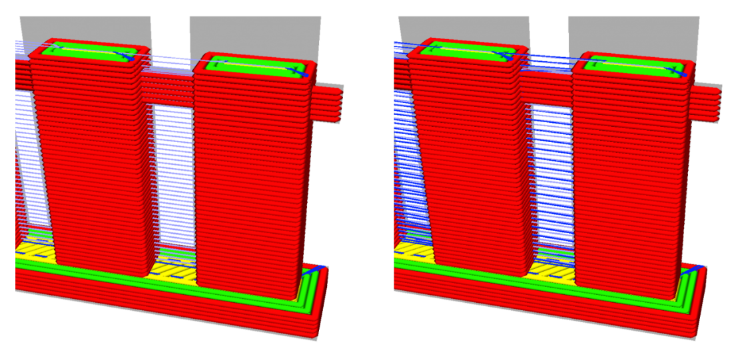This close up of a tiny fence shows retractions (in purple) on the left model. The right model is not allowed to retract (in blue) the short distance between the railing bars due to a minimum travel restriction that is greater than the actual distance

**Maximum retraction count**

The maximum retraction count sets the maximum number of retractions on a certain length of filament (see minimum extrusion distance window). All retractions above this value will be ignored. The benefit of maximizing the amount of retractions is that it decreases the possibility of grinding. However, for models with a lot of holes (e.g. a voronoi print), this can lead to stringing if the value is too low.

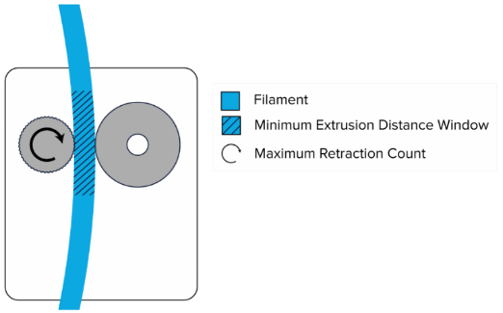Cross section of the feeder

**Minimum extrusion distance window**

This is the length of filament over which the maximum retraction count is enforced. This value protects the number of retractions on the same piece of filament.

For example: If you set the maximum retraction count to 25 and the minimum extrusion distance window to 1.0 mm, it will do a maximum of 25 retractions per 1.0 mm extruded filament.

**Standby temperature**

This refers to the temperature of the nozzle when it is in standby mode, while the active nozzle is printing. The standby temperature is low enough to protect the filament from degrading or clogging, but is high enough to quickly continue printing.

**Nozzle switch retraction distance**

This is the length of the retraction of the filament when the nozzle goes into standby mode. This value is higher than the normal retraction distance, since the nozzle will be in standby for a longer period of time.

**Nozzle switch retraction speed**

This refers to the speed of the retraction when the nozzle switches to standby mode. A higher retraction speed results in a better print, but has a higher chance of causing filament grinding.

**Speed**

**Print speed**

The print speed defines the speed (in mm/s) at which the print head moves while printing. Based on this setting, Ultimaker Cura calculates the extrusion flow. The print speed can be visualized per feature in the *Layer view > Feed rate*.

A higher print speed will lead to a shorter print time. Keep in mind that increasing the print speed means that you may have to increase the temperature as well to ensure the filament is properly melted.

Although you can choose one overall print speed for the complete print, it is also possible to use different print speeds for specific parts of the print:

Infill speed: The speed at which the infill material is printed. If the visual quality of the infill is not important, you could use a higher speed for the infill. However, keep in mind that this may affect the strength of your print.

* **Outer wall speed:** The speed at which the outer walls are printed. Printing the outer wall slower usually results in a better surface finish.
* **Inner wall speed:** The speed at which the inner walls are printed.
* **Top/bottom speed:** The speed at which the top and bottom layers are printed. A lower speed increases the reliability of closure on the top layers, especially for large-area prints.
* **Top surface skin speed:** The speed of the top surface skin layers. These have to be enabled in the shell category.
* **Support infill speed:** The speed at which support structures are printed. The quality of the support is not usually important, so a higher value can often be used here.
* **Support interface speed:** The speed at which support roofs and bottoms are printed. Since these need to adhere to the model properly, they should be printed at a slower speed.

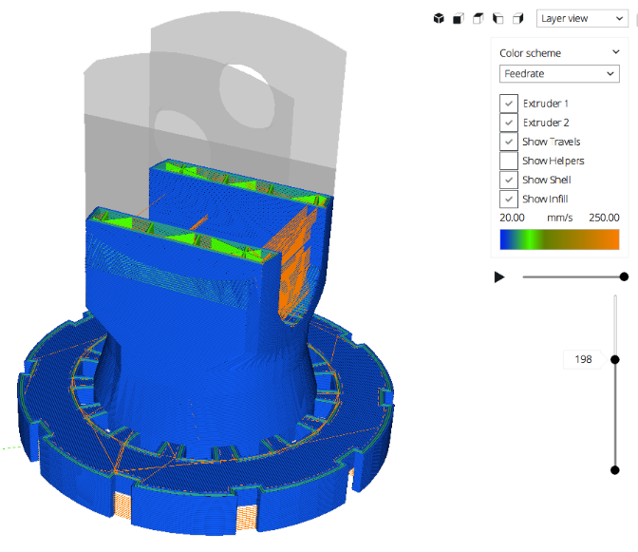This image shows the visualization of the different print speeds per model feature

**Travel speed**

This is the speed at which the print head moves when it’s not extruding. A higher travel speed decreases the chance of filament oozing from the nozzle, resulting in a cleaner object. However, higher speed could also cause the nozzle to hit a previously printed part, which may damage the print due to the heated nozzle. This can be prevented by using Z-hop when retracting.

The travel speed for the initial layer differs from the rest of the print to ensure proper adhesion with the build plate.

**Initial layer print speed**

With this setting, you can specify the speed for the first layer of the print. By default, a low speed is used for the bottom layer, so that the material adheres well to the build plate on the first layer.

**Initial layer travel speed**

With this setting, you can specify the travel speed for the first layer over the print. Keep this setting low to keep the nozzle from pulling the print of the build plate, especially when working with detailed bottom surfaces.

**Skirt/brim speed**

It is possible to adjust the speed at which the skirt or brim is printed. Usually, this is similar to the initial layer speed.

**Maximum Z-speed**

This setting changes the speed for all build plate moves during the print. This includes all layer changes and Z-hops. Normally the Z-speed is set at its maximum and capped by the firmware of the machine.

**Number of slower layers**

This setting defines the number of layers it takes to reach the print speed from the bottom layer of the print. The speed will incline linearly over the number of layers specified, based on the initial layer speed and print speed. A higher value decreases the chance of warping, but can also increase the print time significantly.

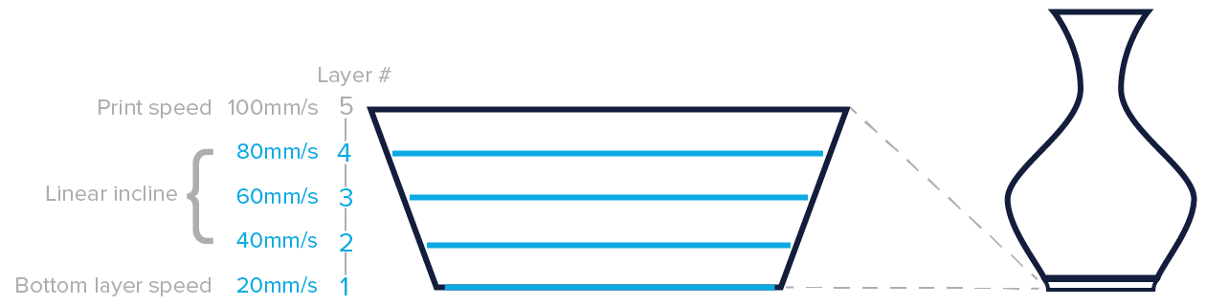In the example above the number of slower layers is set to four, which means that after the fourth layer the set print speed settings will be used

**Equalize filament flow**

This setting allows thin walls to be printed at a higher speed than normal. That way, the extrusion is lowered on the printed part, making it equal to the volume it should extrude.

**Enable acceleration control**

Acceleration is a very important part in printing. Just like a car, the print head needs to accelerate to get to the speeds as explained above. The acceleration reduces the speeds set in the firmware, making the print a little slower, but more accurate. Disable the setting to get the maximum acceleration.

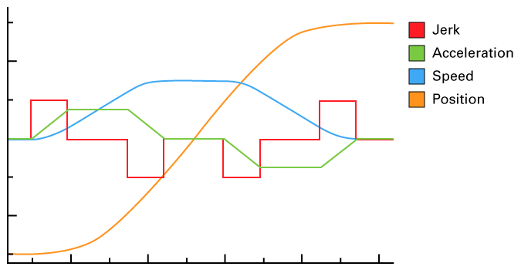This is a theoretical image that shows the difference between speed, acceleration and jerk

**Enable jerk control**

Jerk defines the speed of the print head before performing a hard stop. Just like a car, the print head needs to come to a complete stop at some points. It's comparable to hitting the brakes in a car. When you do this at high speeds it feels uncomfortable. The jerk settings reduce the speeds set in the firmware, making the print a little slower, but more accurate. Disable the setting to get the maximum jerk.

**Travel**

**Combing**

Combing will reduce the chance of defects on outer surfaces of the print by recalculating all nozzle travel moves to stay within the perimeter of the print. This results in greater travel distances, but with a reduced need for material retraction.

If combing is disabled, the material will retract and the print head will move in a straight line to the next point.

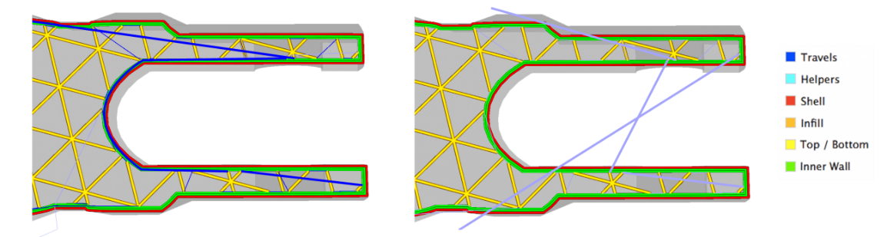Combing enabled (left) has unretraced travel moves within the print’s boundaries. Combing disabled (right) has retracted travel moves which move outside the print’s boundaries.

**Avoid printed parts**

By enabling this setting, the print head will avoid printed parts when traveling. When the shortest route from one point to another in the print is obstructed, the print head will move around it. This decreases the possibility of coming into contact with parts of the model that have already been printed, in turn reducing the chance of surface defects or material mixing. To use this setting, you must first enable combing.

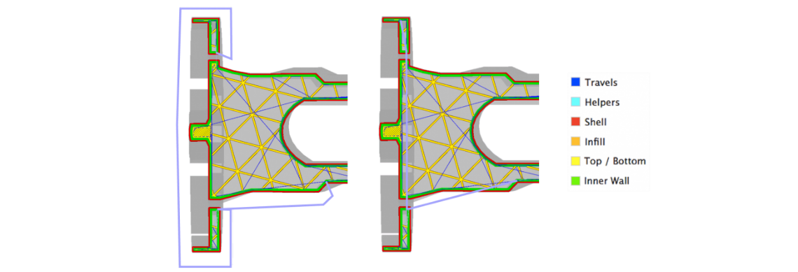The travel moves in both images start and end at the exact same location. Avoid printed parts is enabled for the model on the left, and disabled for the model on the right.

**Avoid distance**

This setting defines the distance (in mm) between the nozzle and the print when avoid already printed parts is enabled. A greater avoid distance means a reduced chance of contact with the printed model, however a large avoid distance will significantly affect the length of the travel moves, impacting the print time, and chance of oozing.

**Layer start X-Y**

This setting defines the position closest to these coordinates to start the next layer. The setting is normally set to the far-right corner because that is where the Ultimaker 3's switching bay is located.

Note: This is a different setting than the Z-seam. The z-seam alignment setting only adjusts the start position of the outer wall, where this setting normally starts at the infill.

**Z-hop when retracted**

With this setting, the build plate will move down by the set value when a retraction is performed, allowing the print head to travel over the print without the nozzle touching it. This prevents the nozzle from hitting the object or leaving “blobs” or scratches on the print surface. Please note that for prints with lots of retractions/travel moves, this can increase the print time.

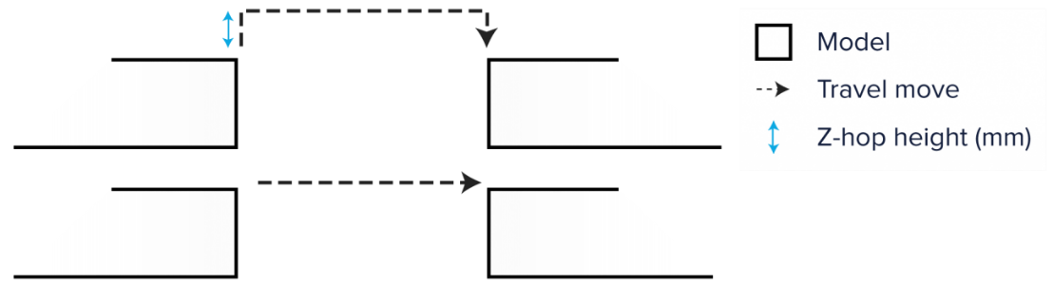

**Z-hop only over printed parts**

The 'Travel' category includes the option 'Avoid printed parts'. When this is enabled, the nozzle will avoid these parts when possible in order to reduce scratching the model’s surface. When there is no way to avoid the part, the printer will perform a Z-hop when traveling over the part.

**Z-hop height**

This setting specifies the height (in mm) at which all Z-hop moves are performed during the print.

**Z-hop after extruder switch**

This feature will trigger a Z-hop when the nozzle moves to the switch bay, reducing the chance that oozed material will come in to contact with the printed model.

**Support**

**Generate support**

Some models have overhanging parts, which means that parts of the model float mid-air when you would print the model. In this case, you must print a support structure under the model to prevent the plastic from falling down. This can be achieved by enabling “Generate support”.

**Support extruder**

Dual extrusion machines offer the possibility to create water-soluble supports. To make use of this feature, you can specify which parts of the support are printed with which extruder. The setting is divided into:

* Support infill extruder
* First layer support extruder
* Support interface extruder
* Support roof extruder
* Support floor extruder

**Placement**

This setting defines where the support structure is printed. It contains the following options:

* **Touching build plate:** Support material is only printed from the build plate up
* **Everywhere:** Support material is printed below every part that needs support, which means that it can also be placed on or inside a model

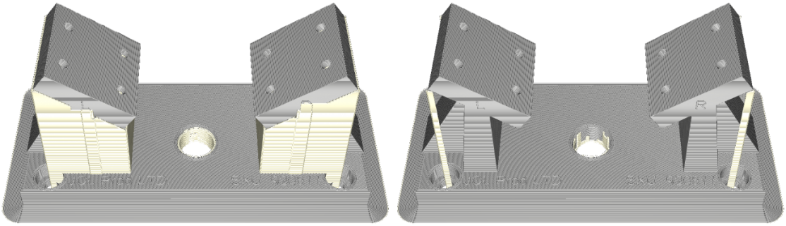This model has parts with overhangs. The model on the left has support everywhere, while the model on the right has support on the build plate only

**Overhang angle**

The overhang angle influences how much support material is added. A smaller angle leads to more support. For example, at a value of 0° all overhangs are supported, while at 90° no support material is added.

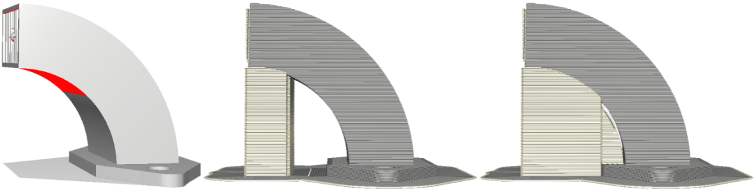The model on the left is shown in the solid mode. The red areas indicate the overhang area that needs support. The model in the middle has an overhang angle of 70°, while the model on the right has an overhang angle of 45°

**Support pattern**

There are different patterns available for printing support structures, resulting in sturdy or easy to remove support. You can choose from the patterns below:

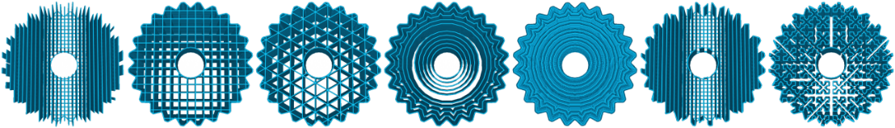

**Connect zig-zags**

When a zig-zag support pattern has been selected, this setting becomes visible. It connects the end of zig-zags, which strengthens the support structure and increases adhesion to the build plate by the support structure.

**Support density**

This defines the density of support structures. A higher value will lead to stronger support, but these will be more difficult to remove and take more time to print.

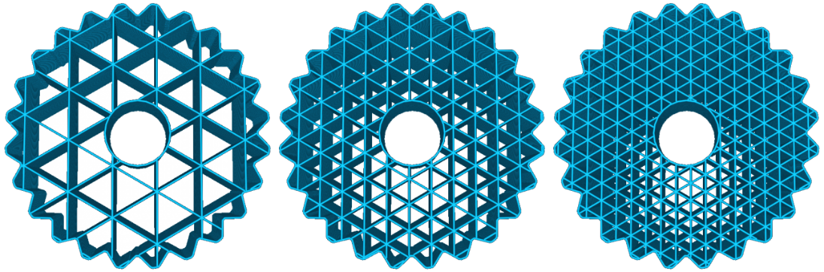This model has triangle support with three different densities: 15 %, 30 % and 45 %

**Z distance**

This refers to the distance from the top and bottom of the support structure relative to the model. This setting is divided into the top distance and bottom distance. The top distance defines the distance between the top of the support and bottom of the model and the bottom distance refers to the distance between the bottom of the support and top part of the model.

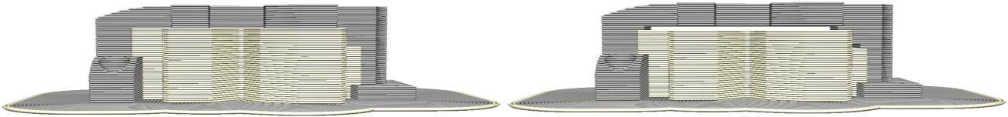

A small distance between the support structure and parts of the model is necessary in order to remove the supports easily after the model has been printed. A low value creates a smoother surface, but can also make it more difficult to remove the support properly.

**X/Y distance**

Under this setting you can adjust the distance between the support structure and the model in the X and Y directions. A higher value reduces the chance of the support structure hitting the model. However, this also creates a larger distance between model and support structure, which may result in smaller overhangs not being fully supported.

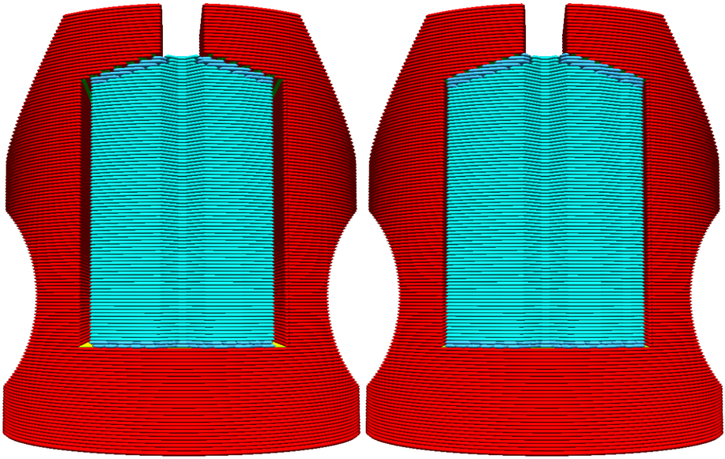The model on the left has a support X/Y distance of 0.7mm, while the one on the right has one of 0.3mm

**Support distance priority**

After the launch of Ultimaker PVA, the support Z-distance was set to 0. This introduced a scenario where the X/Y-distance would offset the PVA from the model, decreasing the support quality. The support distance priority ensures that the PVA aligns with the model perfectly. The image below shows the priority when X/Y overrides Z, and when Z override X/Y.

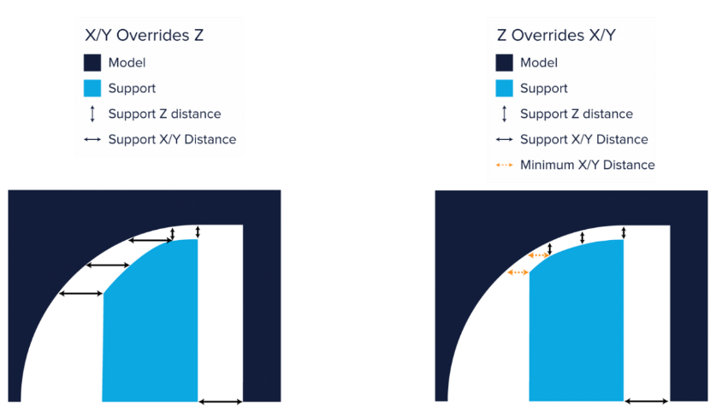

**Minimum support X/Y distance**

When the Z overrides the X/Y-distance priority, as discussed above, the X/Y-distance may force the support to hit the model. To ensure a safe distance, the minimum support X/Y-distance should be kept at all times.

**Stair step height**

When “Support placement type everywhere” is selected, support structures are printed with the model. This structure doesn’t necessarily follow the contours of the model smoothly. Instead, the bottom of the support structure consists of small stair-like steps. Changing the stair step height value affects how big these steps should be. A low value will result in a smoother bottom of the support and more connections between the model and support structure. A higher value makes it easier to remove the support afterwards.

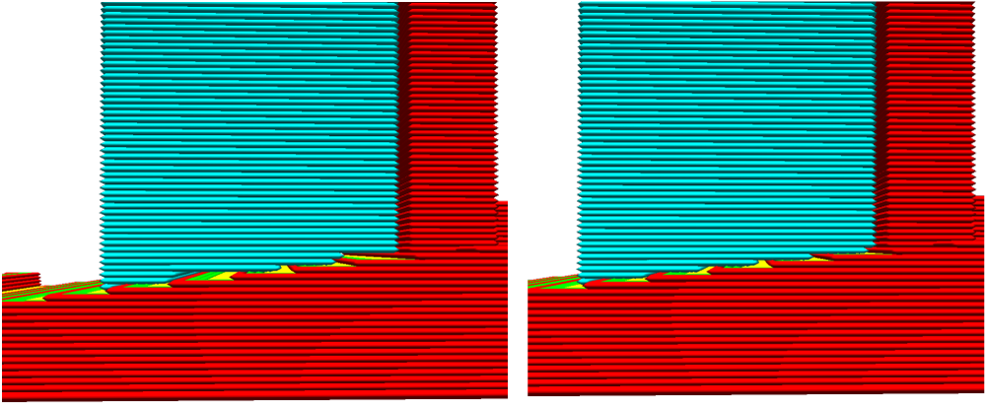The object on the left has a high value stair step height, the model on the right has a lower value

**Support stair step maximum width**

This is the maximum width in the X/Y direction where a stair step appears. When a plane does not change height within these 5 millimeters, the support is handled as regular support.

**Join distance**

Join distance is the maximum distance between support structures in the X/Y directions. When separate structures are closer together than this value, they will merge. Using a high value for this setting will cause support structures will merge sooner. This can help increase the stability and strength of the support, especially when the support structures are very thin. It is important to note that a high value can make the support structures so dense that it is difficult to remove.

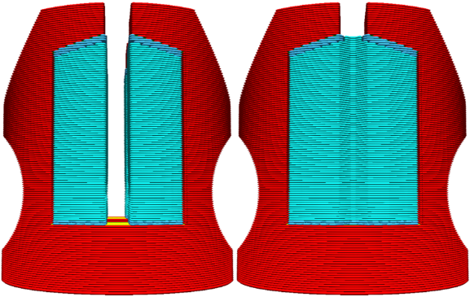The model on the left has separate supports, while the support join distance value of the right model causes the supports to merge

**Support horizontal expansion**

By using horizontal expansion, an offset can be applied to support structures in the X and Y direction. High values will expand the support areas, resulting in sturdier support. Very thin support areas can be removed completely by using a negative value. The right side support of the model below can easily be printed, although the supported area is very thin.

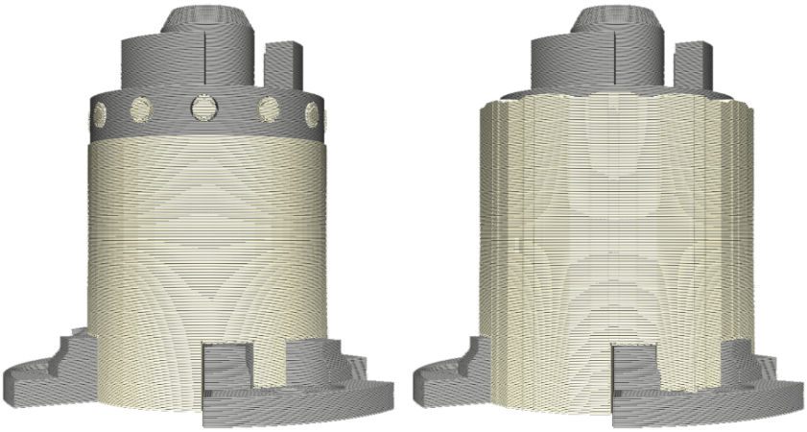The model on the left has horizontal expansion disabled which saves material and decreases print time. The model on the right has horizontal expansion enabled, which increases the strength of the structure

**Enable support interface**

A support interface generates a dense skin on the roof and floor of the support structure on which the model is printed. Doing this supports the bottom layer of the print better, leading to a more even surface. It is important to remember that a support roof is more difficult to remove than regular support, so post-processing may require more work, specifically when using non-soluble supports.

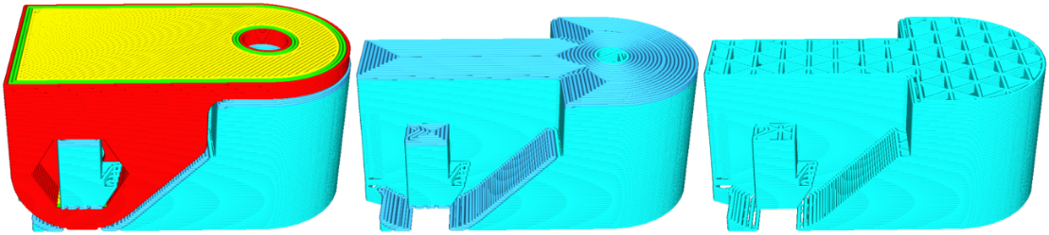This model is sliced in two different ways: the example in the middle has the support interface enabled, while the right example has the support interface disabled

The support roofs and floors can be set separately and each has its own options:

* **Support interface thickness:** The thickness of the support interface(s)
* **Support interface resolution:** The resolution checked in the Z-direction, which determines where support interface is printed
* **Support interface density / line distance:** The density of interface of the support structure
* **Support roof pattern:** The pattern that determines how the roof of the support structure is printed

**Use towers**

By enabling this setting, support structures are printed as towers that reinforce tiny overhang areas. Support towers are only printed for support areas that are smaller than the set minimum diameter. All support areas larger than this value will use regular support.

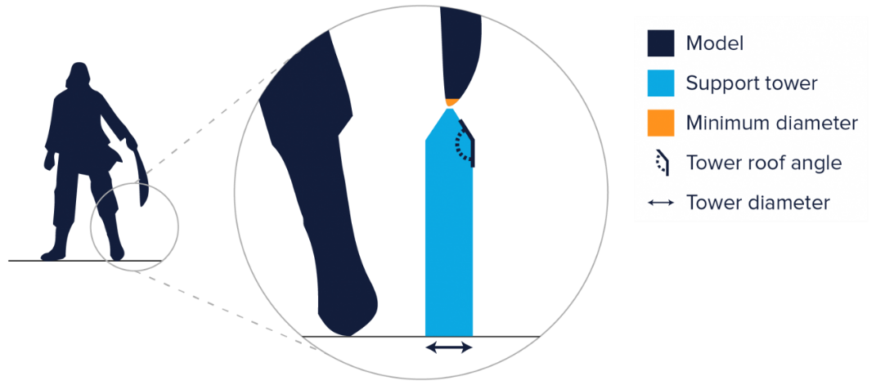

To improve stability, support towers have a larger diameter than the region they support. If necessary, the tower diameter can be changed to create either a bigger or smaller support tower. The tower’s diameter decreases near the overhang, forming a roof. Adjusting the tower roof angle defines how sharp or flat the tower roof should be.

**Cooling**

**Enable cooling fans**

With this setting you can enable or disable the print head fans during printing. The print head fans ensure that the material is cooled properly before the next layer is printed. For layers with a short layer time, and those with bridges/overhangs, cooling will increase the print quality.

**Fan speed**

When the print head fans are enabled, you can adjust certain parameters. One of these is the fan speed – the speed at which the fans spin. A higher speed allows for better cooling and reduces oozing, but can also increase the shrinkage of the material. This is why the speed may be different for different materials. The preset material profiles on the Ultimaker already contain the default values for Ultimaker materials.

This setting is divided into the following parameters:

* **Regular fan speed:** The speed at which the fan spins before hitting a threshold. When a layer prints faster than the threshold, the speed gradually increases towards the maximum fan speed
* **Maximum fan speed:** The speed at which the fan spins on the minimum layer time. The fan speed gradually increases between the regular fan speed and maximum fan speed after the threshold is hit

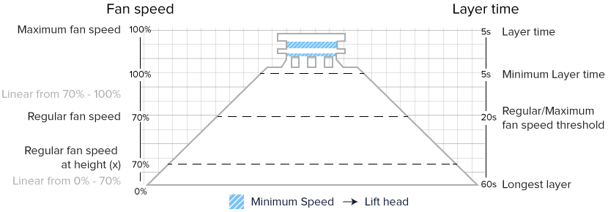An overview of common cooling settings combinations, projected onto a pyramid model

**Regular/maximum fan speed threshold**

This setting defines the layer time at which the fan will switch between regular fan speed and maximum fan speed. Layers that print slower than this time use the regular fan speed. For faster layers the fan speed gradually increases towards the maximum fan speed.

**Regular fan speed at height**

This is the height at which the fans will increase to full speed. In the layers below, the fan speed will gradually increase from zero to regular fan speed.

It’s also possible to change this parameter by adjusting the layer number at which the fans should be on full speed.

Using a higher value increases the adhesion to the bed, but can also lead to oozing and a reduced print quality. Printing with the fans on full from a height of 0.5 mm is usually sufficient.

**Initial fan speed**

This controls the fan speed on the initial layer only, which adheres to the build plate. The speed then changes back to the regular fan speed, which is achieved once it reaches the height setting for the regular fan speed.

**Minimum layer time**

The minimum layer time determines the time it should take to print one layer. If a layer would normally take less time than the set value, the printer slows down, so that the minimum layer time is reached. This allows the printed material to cool down properly before printing the next layer.

**Minimum speed**

This is the minimum speed at which the printer is forced to print, despite slowing down to the minimum layer time. When the printer slows down too much, the pressure in the nozzle is too low and results in a bad print quality.

For example, if a minimum layer time of 5 seconds requires the printer to print at a speed of 8 mm/s, it will only do that if at least 8 mm/s is set as minimum speed. If the minimum speed is set at 10 mm/s, that means that it won’t print slower than 10 mm/s and that the layer time will change accordingly, and would then be shorter than 5 seconds.

**Lift head**

By enabling this setting, you allow the print head to move away from the print during printing, while at the minimum speed, but when it has not yet reached the minimum layer time. The print head will wait until the minimum layer time has passed and will then move back to the print to continue. This gives the printed material enough time to cool down while at the minimum speed.

**Build plate adhesion**

**Enable prime blob**

This setting is for dual extrusion machines only. The printer normally starts with a blob of material, to prime the nozzle. Disable this setting to use the skirt or brim to prime the nozzle instead.

**Build plate adhesion extruder**

This setting determines which extruder prints the selected build plate adhesion method. This setting is only available in dual extrusion machines.

**Build plate adhesion type**

There are three types of build plate adhesion: skirt, brim and raft. You can also easily disable the adhesion types by setting it to None.

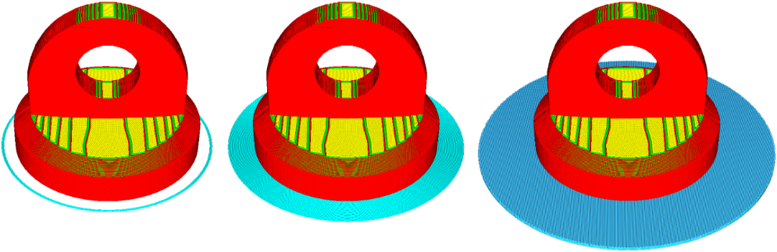

This model has the build plate adhesion types from left to right: skirt, brim and raft

**Brim**

Brim adds a single layer flat area around the base of the model to prevent warping. The brim is connected to the model and makes the bottom surface area bigger. This increases the adhesion to the build plate and, in case of warping, the corners of the model are less likely to curl up because of the brim attached to it.

Materials that have a high potential for shrinkage (e.g. ABS) can benefit from using a brim. Models that have a very big base or very thin parts at the bottom will also stick better to the build plate with a brim.

There are multiple options available for the brim setting:

* **Brim minimum length:** The length in millimeters here is the amount of filament that is extruded, regardless of the other brim settings
* **Brim width:** This setting adjusts the width of the brim in millimeters
* **Brim line count:** This setting overrides the brim width, setting the width by the number of printed lines
* **Brim only on outside:** This setting ensures that models with holes on the initial layer, like a donut shape, only have brim on the outside of the model

**Raft**

A raft adds a thick grid with a roof between the model and the build plate. This can be useful when the bottom surface of a model is not completely flat or has little adhesion to the build plate. A raft ensures that the model will stick better to the build plate.

The raft options in Ultimaker Cura are extensive. The raft is divided into three parts: top layers, middle layers and base layers. The image below explains the raft settings that are available. It is important to know:

* **Initial Z overlap:** This setting lowers all layers of the model, except the initial layer, to compress the initial layer against the raft.
* **Raft base layer:** This layer needs to be pressed right up against the build plate and therefore looks oversized.

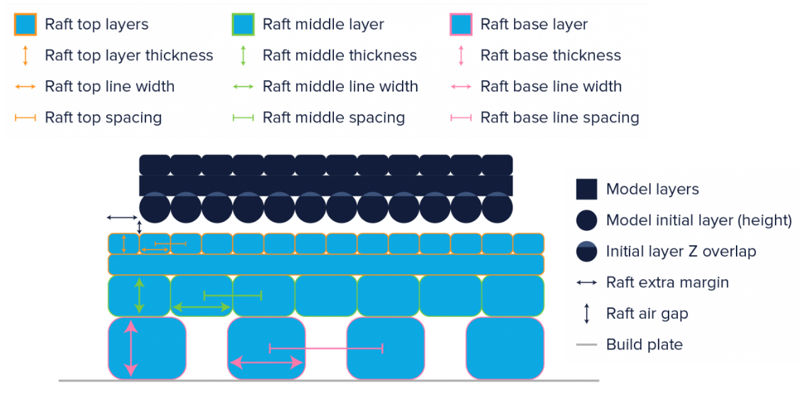A visualization of the raft settings in Ultimaker Cura

The final result when printing with the raft as visualized above will end up like in the image below.

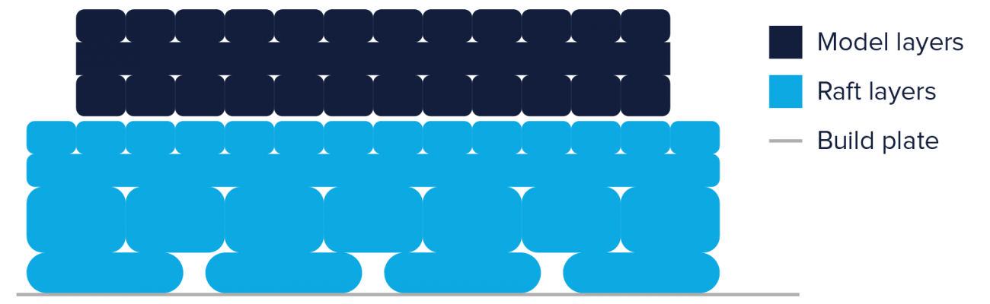The result of the printed raft

**Skirt**

A skirt is a line printed around the object on the first layer, but not connected to the object. This helps prime the extrusion nozzle and can be an additional check for bed leveling before the print begins.

If you select a skirt, you can adjust the following parameters:

* **Skirt line count:** The number of skirt lines printed around the model
* **Skirt distance:** The distance between the model and the skirt
* **Skirt minimum length:** The total length of the skirt. This will override the skirt line count when the minimum length is not reached yet

**Dual extrusion**

**Enable prime tower**

A prime tower is an additional print that's created on the build plate to help prepare the nozzle before printing the next layer. It reduces oozing, under extrusion and enhances overall printing quality. The prime tower has a few settings that can be adjusted.

* **Prime tower size:** The size in the X/Y direction of the prime tower. A larger footprint creates a more stable prime tower
* **Prime tower minimum volume/thickness:** The volume of the prime tower. The volume must be enough for the nozzle to prime properly
* **Prime tower X/Y position:** The position of the prime tower as seen from the origin point in Ultimaker Cura. It is located near the switching bay by default to reduce printing time
* **Prime tower flow:** The overall flow of the prime tower. This is set to 100% by default

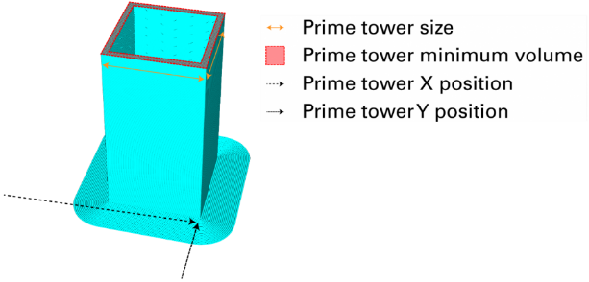This image shows the behavior of the above settings

**Wipe inactive nozzle on prime tower**

After printing the prime tower with the active nozzle, the inactive nozzle wipes itself off on the tower. This cleans the nozzle to reduce the chance of oozing on the printed model.

**Wipe nozzle after switch**

After a nozzle switch, the active nozzle moves to the infill of a printed part and slowly wipes itself off on it. This cleans the nozzle before continuing the printing process.

**Prime tower purge volume**

To ensure the prime tower is sturdy and capable of holding all the oozed material, the nozzle purges a small volume inside the tower. The tower acts like a waste bin and collects all excessive material.

**Enable ooze shield**

The ooze shield is a separately printed one-layer wide wall, which catches ooze from incoming nozzles before each layer is printed. It is recommended that this setting is only used when printing with the Ultimaker Original dual extrusion experimental kit. It has two separate settings that can be controlled:

* **Ooze shield angle:** The maximum angle of the ooze shield. This is to prevent the shield from collapsing
* **Ooze shield distance:** The distance between the ooze shield and the model. This is used to prevent the shield from merging with the model

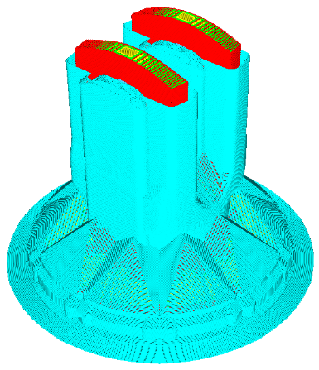This model is printed with the ooze shield enabled. The ooze shield needs to be removed after the print finishes, revealing the underlying model

**Mesh fixes**

The below settings can be used to fix errors in models that are not properly designed for 3D printing. These models usually look good in the solid view, but if there are faults these are often shown as red areas in the X-ray view.

**Union overlapping volumes**

If a model contains two volumes that interfere (as if they were placed through each other), this setting allows you to fix that. Union overlapping volumes will recognize these interferences and try to slice it as one volume.

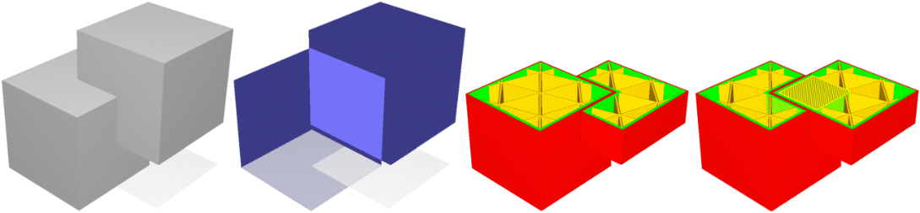These two cubes overlap and produce invalid geometry by default. From left to right: solid view, x-ray view, “Union overlapping volumes” disabled, and with “Union overlapping volumes” enabled

**Remove all holes**

Solid models that contain unnecessary holes on the inside can be repaired by enabling the “Remove all holes” setting. Ultimaker Cura then closes the holes for slicing and makes sure the inside is printed correctly.

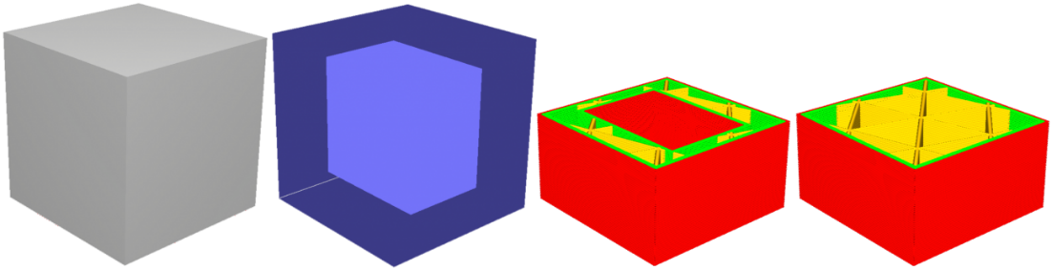This cube is hollow and will take longer to print than just making it solid, because of the extra walls. From left to right: solid view, x-ray view, “Remove holes disabled”, and “Remove holes enabled”

**Extensive stitching**

When polygons are missing in the shell of the model, Ultimaker Cura won’t be able to slice the model correctly. In this instance, you will see faults in the shell and/or infill in the layers view. By enabling “Extensive stitching” holes in the shell will be closed so that it can be sliced as expected.

**Keep disconnected faces**

Models that contain holes on corners are ignored by Ultimaker Cura. It’s impossible to know how the missing geometry should look. With this option enabled, Ultimaker Cura connects all neighboring geometry to close the model.

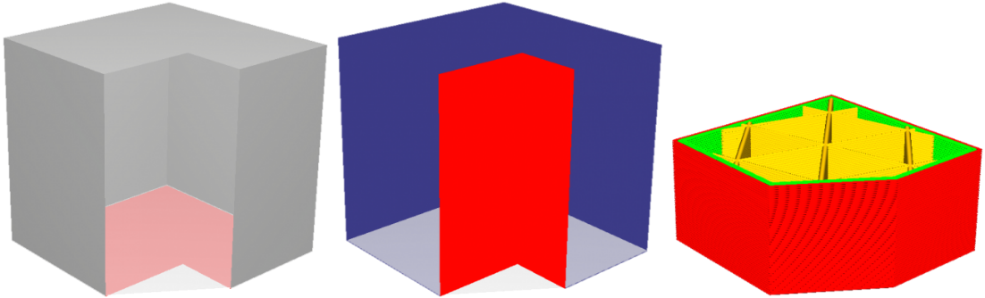This model is missing geometry that connects to multiple neighboring polygons. Without knowing this should be a cube, Ultimaker Cura cannot connect the faces, and therefore produces nothing. From left to right: solid model, x-ray view, and “Keep disconnected faces” enabled

**Merged meshes overlap**

This setting creates an overlap where merged models meet. The result is a slight over-extrusion on the joining areas, which can improve adhesion between the two parts. Keep this setting low, between 0.0-0.2mm, to prevent too much over-extrusion.

**Remove mesh intersection**

Ultimaker Cura detects if meshes loaded on the build plate overlap. If they do, Ultimaker Cura partly removes one of the meshes to prevent extruding double on those parts.

**Alternate mesh removal**

When Ultimaker Cura detects overlapping meshes, it normally removes one of the meshes completely. With this option, the meshes are alternatively printed layer by layer, creating a woven mix of the two.

**Special modes**

**Print sequence**

When multiple models are placed on the build plate, you can define the sequence in which they should be printed. This option is only available on single extrusion machines. There are two options:

* **All at once:** All objects will be printed at the same time, which means that it will print one layer of each object before moving onto the next layer
* **One at a time:** Objects will be printed one by one. This mode can only be used if the models are smaller than the gantry height, which is the distance between the build plate and lowest print head shaft

**Mold**

The selected model will be printed in negative, with a wall surrounding it, so you can use the finished print as a mold for other materials. There are a few parameter options available:

* **Minimal mold with:** This specifies the minimum width of the mold
* **Mold roof height:** This specifies the height of the mold above the horizontal parts in your model
* **Mold angle:** This is the maximum angle the mold may make outside of the model. That way, there is no support needed on the outside of the mold.

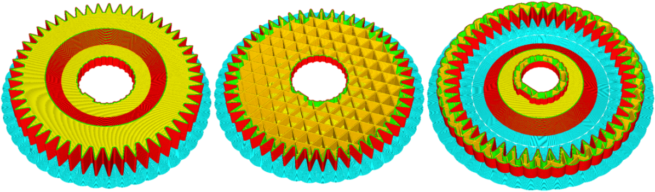This model is sliced normally and with the mold option enabled

**Surface mode**

In surface mode, the printer will only print the X-Y surface of the mesh (walls), instead of the solid model. Top and bottom, infill, and supports are not generated in this mode. This was previously called “Only follow mesh surface”. In addition to the “surface mode” and “normal”, a “both” mode has now been added. This ensures all closed volumes are printed as normal, and all loose geometry is printed as a single wall.

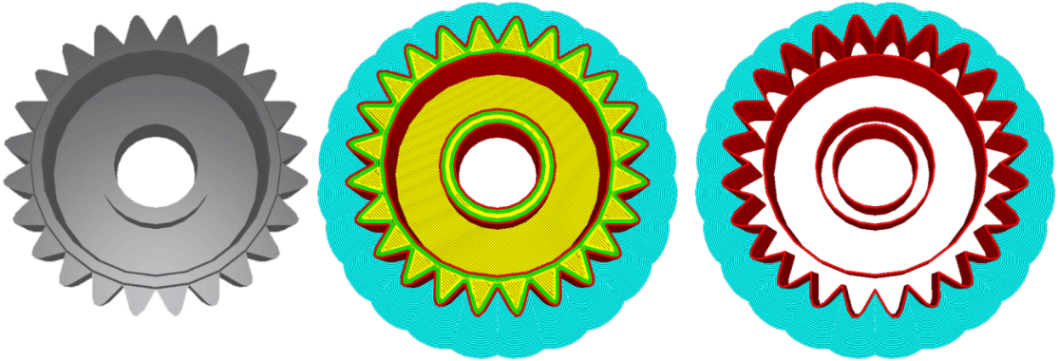This mode prints a shell quickly and efficiently. It is often used to print quick rings and other single-shelled models

**Spiralize outer contour**

Typically, the Z-stage moves up by the layer height after printing a complete layer. Spiralize mode smooths out the Z move over the edge. This means that the Z-stage will gradually move down over the whole print, like a spiral. Solid objects are turned into single-walled prints with a solid bottom by using this option, which is perfect for printing items like vases, for example.

**Experimental**

The settings in this category are experimental and should be considered carefully before use. They may result in failed prints.

**Tree support**

Instead of printing supports up in straight lines from the build plate, we can use tree support to print tree-like structures that support models. These supports are hollow and can be designed to follow different angles. The following parameters control the way the supports grow.

* **Tree support branch angle:** The maximum overhang angle the branches may use to print sideways
* **Tree support branch distance:** The distance between the endpoints of branches, for example, where they touch the model. It is comparable to the support density
* **Tree support branch diameter:** The diameter of the branch where it touches the model
* **Tree support branch diameter angle:** The growth angle of the branch. A bigger angle increases the branch’s bottom width
* **Tree support collision resolution:** The X-Y resolution to check the loaded model and avoid collision
* **Tree support wall thickness:** The thickness of the outer wall of the tree branches

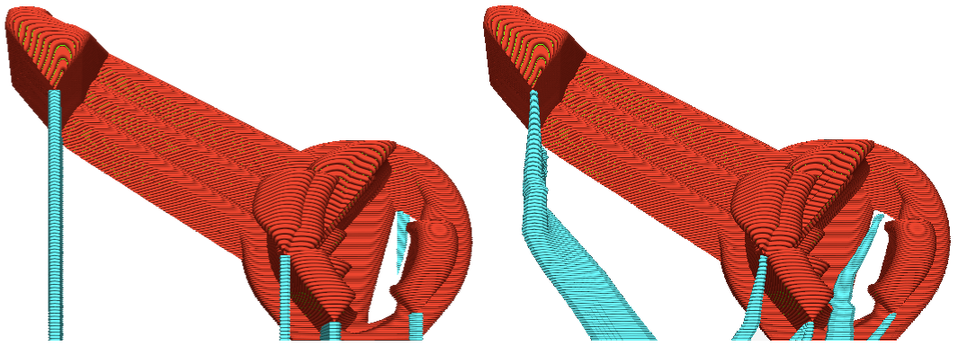

**Slicing tolerance**

Slicing tolerance defines the way sloped areas are sliced. As visible in the image below, a layer is sliced in 2D at a particular height. However, depending on the layer height, the layer is actually 3D. The layer can be sliced in three ways.

* **Inclusive:** Slice at the outermost part of the layer, always including the model
* **Middle:** Slice at the middle of a layer. This is the standard setting
* **Exclusive:** Slice at the innermost part of the layer, allowing the model to be bigger than the actual slice

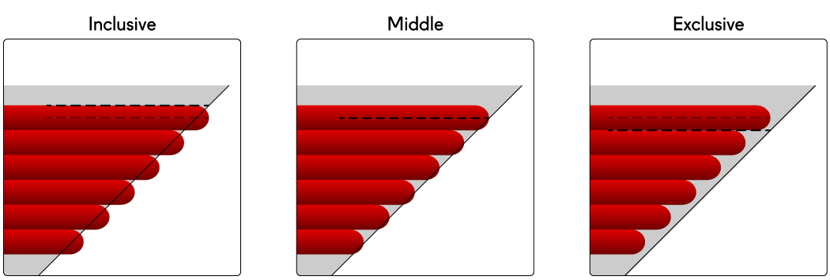

**Top surface skin**

Top surface skin prints a number of skin layers. To enable these options, first set a number of top surface skin layers, which can be found under the Shell category.

* **Top surface skin line width:** Adjusts the line widths of these layers
* **Top surface skin pattern:** Adjusts the pattern of these layers
* Top surface skin line directions: When the pattern is set to zig-zag or lines, a user can adjust the line direction in degrees here. Multiple directions should be separated by commas

**Infill travel optimization**

Travel moves of infill lines are not always ideal. This setting enables an optimization that reduces travels between the infill lines. However, it is important to note that this setting might increase print time when used on models with many separate shells.

**Maximum (travel) resolution**

These settings define the maximum resolution for each horizontally printed line. This is used to remove unnecessary detail in printed curves and curved travels, resulting in a smaller GCODE file and putting less stress on the printer’s processing power.

**Break up supports in chunks**

This setting divides zig-zag pattern support into separate structures by adding small gaps. This allows support structures to be easily pulled away piece by piece. It will not affect the support capacity of the reinforcing structure.

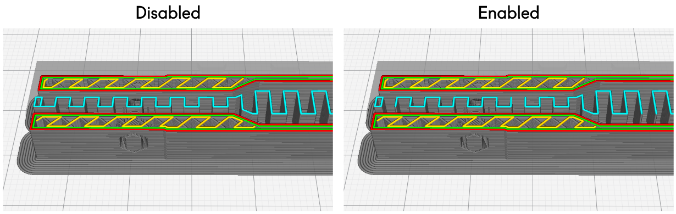

**Enable draft shield**

A draft shield will create a one-layer thick wall around the object, which protects it from unwanted air flows from the environment. Materials that are prone to warping or delaminate easily (e.g. ABS) can benefit from this feature.

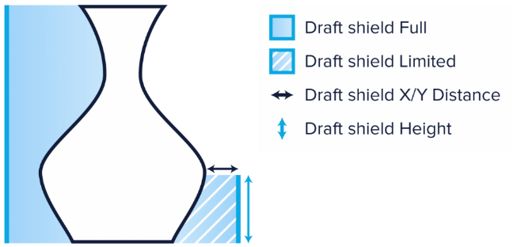This model of a vase uses a draft shield to prevent warping

There are a few draft shield parameters that can be set.

* **Draft shield X/Y distance:** The distance between the draft shield and the object
* **Draft shield limitation:** This allows the printer to print the draft shield to the full height of the object, or to a limited height
* **Draft shield height:** The height at which the draft shield will be printed when the draft shield limitation is set to “limited”

**Make overhang printable**

This setting converts all geometry that has a bigger overhang than specified in the “maximum model angle” setting to the value set there. When using this setting, the shape of the model is altered and the model will print differently.

**Enable coasting**

Coasting replaces the last part of an extrusion path by a travel move. This way excess pressure is released from the nozzle, decreasing the likelihood of material leaking from the nozzle while traveling. Too much coasting, however, can lead to under extrusion as the pressure inside the nozzle drops during the travel move.

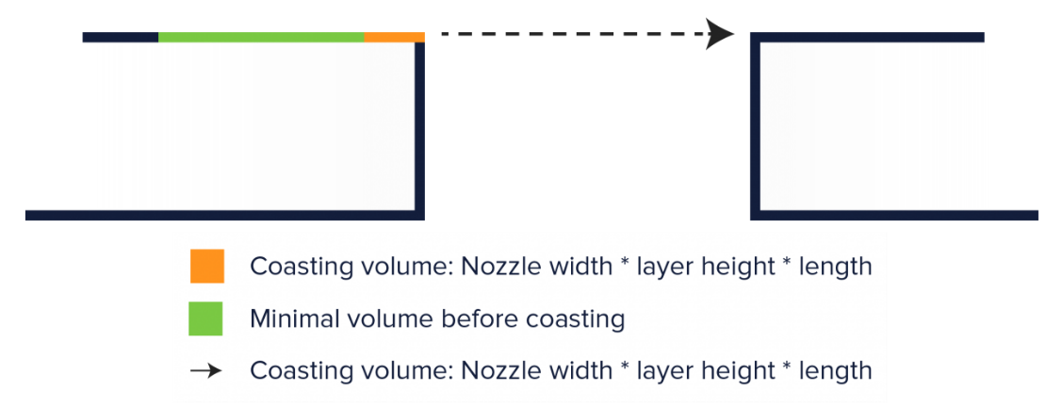

When coasting is enabled, you can adjust the following parameters:

* **Coasting volume:** The volume of material that is coasted
* **Minimum volume before coasting:** The minimum volume an extrusion path should have before allowing coasting
* **Coasting speed:** The speed of the coasting move as a percentage of the print speed. Since the pressure is released from the nozzle, a value slightly below 100% is advised

**Alternate skin rotation**

Usually the top and bottom layers are printed diagonally, and in different directions every alternating layer. With alternate skin rotation, the direction of the top and bottom layers will swap between the two diagonal directions, and print in the X or Y direction only. This helps close the top layer better and decreases the chance of pillowing. This setting only works with lines and a zig-zag bottom/top pattern.

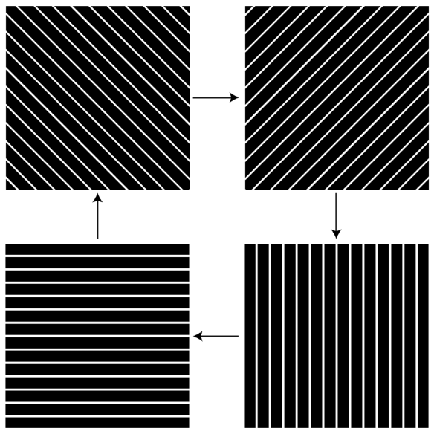Alternate skin rotation visualized

**Spaghetti infill**

Print the infill every so often, so that it will end up in the model in a chaotic way. This will print infill faster but will also reduce the model stability.

**Conical support**

This is an experimental feature which creates support structures that are small at the bottom and wide at the top. Using conical support can save up to 50% of support material. It also provides option of printing an overhanging support structure over your model, to support parts on the top surfaces of the model, without using the option support throughout the print.

**Design guidelines**

Designing parts to print with engineering materials can be more challenging than using materials such as PLA. Some engineering materials have a higher tendency to shrink, causing warping. To combat this, there are ways to optimize the design of your model.

A well-designed model that follows these guidelines and uses Ultimaker Cura’s recommended profiles will help to improve the print reliability.

The diagram below shows some useful features that work well for 3D printed parts:

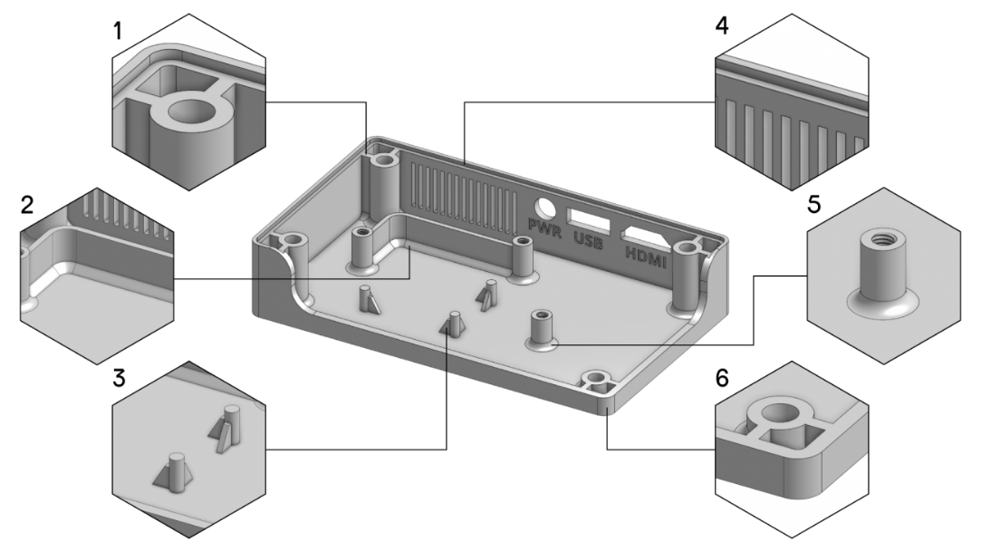

1. Rib
2. Chamfer
3. Gusset
4. Wall thickness
5. Fillet
6. Rounded corners

**Rib.** A rib is a special type of extruded feature that adds material of a specified thickness in a specified direction between the contour and an existing part. Not only does it connect the part to a wall to further strengthen it, but it also supports the part from the bottom surface.

**Chamfer.** These can be added to corners to reduce stress points. Avoiding sharp corners results in less accumulation of stress when printing.

**Gusset.** A gusset helps support a feature of the part from the bottom surface. Unlike a rib, it tapers off as the Z height increases.

**Wall thickness.** Generally, designs with a uniform and consistent wall thickness decrease the chance of warping or shrinkage.

**Fillet.** Similar to chamfers, fillets reduce stress points and reduce the accumulation of stress when printing.

**Rounded corners.** These distribute the stress in the material throughout the model, which will improve the quality of the print.

The table below shows the design features for each material:

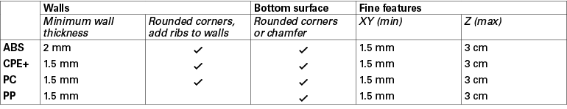

**Fine features.** x=y=1.5 mm for features where z = max. 3 cm (For example, a pin feature of 3 cm should have a minimum diameter of 1.5 mm. For a taller feature the diameter should be increased).

**Printing guidelines**

Although the profiles in Ultimaker Cura are completely optimized for Ultimaker printers and materials, they may need some adjustment in specific cases. Sometimes, warping and delamination can occur despite the use of the default profiles, because of the shape and size of the model and material choice. In these cases, and when changing the design and/or material is not possible, it is recommended to take a look at the fan speed and print speed. Adjusting these settings according to the instructions below can help to improve print quality.

**Fan speed**

The fans on the sides of the print head cool the material after it has been laid down. This is important as the layer has to solidify before the next layer is printed on it. However, excessive cooling can cause materials to contract too much, as they tend to shrink when cooling down fast. Especially engineering materials such as ABS, CPE+, PC, and PP are prone to this. Although the print head fan speed has been optimized for these materials in the profiles, there is a small chance that for some specific models warping or delamination still shows up.

In this case, it can help to further decrease the fan speed, to 0 or 1%. You can do this in Ultimaker Cura by going to the Custom settings in the Sidebar, then search for the setting Fan speed and change it. Some of the materials are already printed with the fans off, but for others it is possible to decrease it. Especially for mechanical prototypes this can help to improve the layer bonding and build plate adhesion.

**Print speed**

Another way of improving the layer bonding and reducing the chance of delamination is lowering the print speed. Although the default profiles, in general, enhance good interlayer adhesion, it can in some specific cases help print a bit slower, so that the layer bond even better. If you decide to change this, it is recommended to lower the print speed by 20%. This can be done in the Custom settings in Ultimaker Cura. Look for the setting *Print speed*, and then change it to a value that is 20% lower than the original value.

**Maintenance**

How to apply the Atomic Method?

**Tip:** Besides using this method to unclog the nozzle, you can use the Atomic Method when switching to a material that requires a lower printing temperature. This way all residue from the previous material will be removed, helping to prevent blockages.

**Note:** Make sure you move the print head to a corner of your printer to prevent bending the axles.

Removing the material

**Remove the material from your printer.**

* Remove the bowden tube by pressing down the tube coupling collet and pull the bowden tube out of the print head.

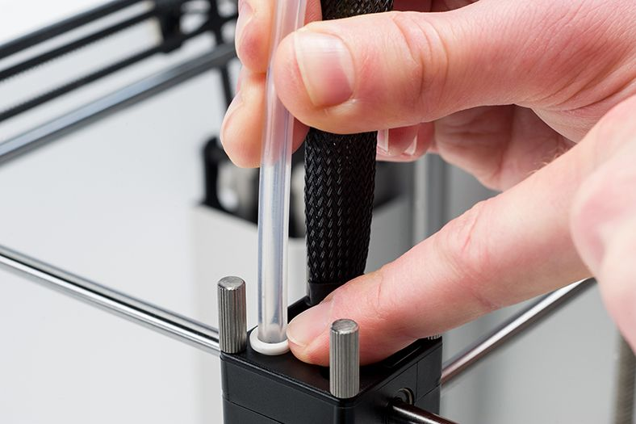

**Heating up and preparing**

Heat the nozzle of your printer to the temperature of your last used material.

1. Cut off approximately 20 cm of filament (of your last used material) with a straight cut and try to straighten it as much as possible.
2. Wait until the nozzle has heated up and then insert the piece of material in the print head, all the way down into the nozzle.
3. Push the material slightly until it either comes out of the nozzle or cannot be pushed any further.

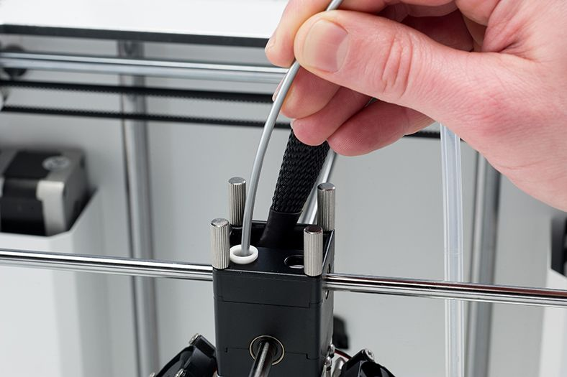

**Removing the material**

1. Lower the temperature to 90° C for PLA. For ABS you will need 110° C.
2. Wait until the temperature is reached and then pull the material out with a quick, firm pull.
3. Check the color and shape of the tip of the filament. The goal is to have a clean, cone-shaped tip.
4. Repeat the steps ‘Heating up and preparing’ and ‘Removing the material’ until the filament comes out without any residue and has a cone-shaped tip.

**Note:** It is important to pull the material out quickly. If you pull it out too slow, the filament will stretch.

[**Troubleshooting**](https://ultimaker.com/en/resources/troubleshooting)

**Under-extrusion**

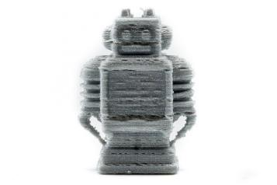In its simplest form, under-extrusion is when the printer is unable to supply the right amount of material. You’ll know if your printer is under-extruding as you’ll see missing layers, very thin layers, or layers that have random dots and holes in them. This problem is probably the trickiest to find the direct cause as there are so many variables to consider, but we’ll take you through them here and give you helpful pointers to remedy it.

Ultimaker robot shows signs of under-extrusion

**Note:** If your print is just missing a single layer in the print, this is not under-extrusion. In this case there’s a ‘skipped layer’ problem, as described here: https://support.3dverkstan.se/article/23-a-visual-ultimaker-troubleshooting-guide

**Material and material settings**

The first and easiest things to check if your print is suffering from under-extrusion are the material settings. It’s important that the material profile on your printer (or material settings in Cura) matches the material. For example, a temperature setting that’s either too high or too low can lead to problems. When the temperature is too low, the material won’t melt properly as cooler plastic is more viscous and requires higher pressures to push it through the nozzle. Eventually, the pressures will simply become too high and under-extrusion happens. On the other hand, when the temperature’s too high, it can cause problems as the properties of the material will start to change if left in the nozzle for too long, causing clogs. Please check your filament spool for the proper temperatures.

Closely related to the temperature are the nozzle size, the print speed, and layer height. These settings define the flow rate, which is the volume of material that is extruded per second. If you want to push through more material than your printer is capable of, this will lead to under-extrusion. There should always be a good balance between the temperature and speed. At higher temperatures, you can print faster, but when printing at lower temperatures you might have to decrease the speed to get a proper extrusion.

Besides material settings, it’s also possible that the material itself is causing the problem. For example, the filament can sometimes get tangled after removing it from the 3D printer – this is where it gets stuck before entering the feeder. Therefore, it’s always a good idea to check that the filament isn’t overlapping on the spool before you start printing.

Another reason can be the absorption of too much moisture by the filament. Some materials (especially PVA) are very sensitive to moisture and can lose quality when used or stored in a humid environment for too long. Correct handling and storage of the material are very important in this case.

**The feeder**

The feeder is the part of a printer that literally ‘feeds’ material into the 3D printer and is, therefore, the first component that could cause extrusion problems. A few symptoms that could indicate your feeder is causing under-extrusion:

* The material is hardly moving towards the hot-end
* Material grinds in the feeder
* The feeder is ticking back/skipping

When the material doesn’t move through the bowden tube and hot-end properly, it could mean there’s friction in the bowden tube or hot-end, or that the feeder doesn’t have enough grip on the material. In the latter case, the feeder tension could be too low. This can easily be diagnosed by taking the material out of the 3D printer and checking if there are visible marks on the material. If the material is completely smooth, it means the feeder tension is too low.

Marks on material means good feeder tension

No marks on material means too low feeder tension

Grinding of the material means too high feeder tension

Contrary to this, it can also be that there’s too much tension on the feeder. When this happens, the material is basically being ‘squeezed’ in the feeder, causing it to flatten and can’t be pushed further. Consequently, the feeder will dig into the material and ‘eat it away’. This is called grinding. Additionally, the feeder could also start making a ticking sound or skip back. Grinding and skipping can also occur when there’s a blockage in the hot-end, but this will be described in more detail later on in this guide. When your filament is ground down, it’s important to remove the material from the printer, clean the feeder and check the feeder tension before continuing.

**The bowden tube**

Once the material has passed the feeder, it will be forwarded through the bowden tube. It’s possible the material could actually experience friction in the bowden tube, leading to under-extrusion. There are a few possible reasons for this friction.

When the filament has been ground down, there’s a good chance that small particles from this ‘grinding’ have entered the bowden tube. These particles can cause friction in the bowden tube and eventually lead to under-extrusion. That’s why it’s best practice to check the bowden tube is clean if filament has been ground down inside it.

Friction in the bowden tube can also be caused by the filament on the spool. Towards the end of the spool, the coils are usually small and tight. When going through the bowden tube the filament will experience higher friction than if the filament was nice and straight. If you’re printing at the limit of what the printer can achieve, this additional friction can be enough to cause problems with your print.

**The hot end**

From time to time, you may experience under-extrusion due to a problem with the printer’s hot-end.

First of all, there could be a partial blockage in the nozzle, stopping the filament from running through properly. Such a blockage is often caused by some dirt or carbonized material in the hot-end.

Another hot-end related cause for under-extrusion could be a bad adjustment of the hot end itself (for example after you’ve replaced it). It’s important that parts fit well together so that there’s no distance in-between them. If the parts haven’t been placed correctly, there’s a chance that material will leak in-between them and eventually cause clogs in the hot-end.

**How to fix pillowing**

When the top surface of a print is not completely closed or shows bumps, we call this pillowing. This behavior mainly appears because of wrong print settings and bad cooling. On this page we describe what you can do to get rid of pillowing on your prints.

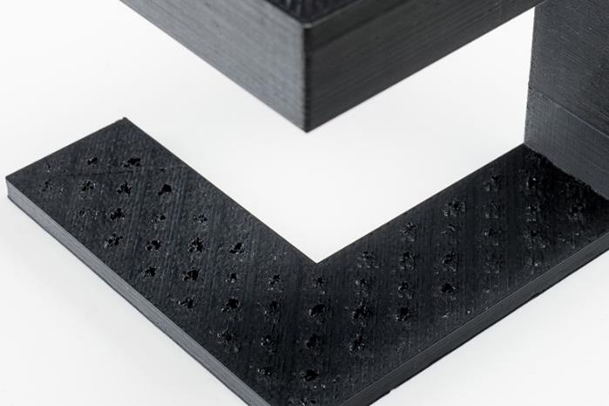

**Top/Bottom thickness**

To create a smooth top surface, it’s important to use a thick enough top on your print. A too thin top thickness will logically lead to a top surface with holes in it. Thus, increasing the Top/Bottom thickness in Cura will help to better close the top surface of your print. We advise to use a Top/Bottom thickness of at least 6 times the layer height to properly close your model if it has a flat top surface. This means for example that you need a Top/Bottom thickness of 0.6 mm when using a 0.1 mm layer height. If the top surface of your print is not properly closed you could increase the Top/Bottom thickness. In general, we can say that the thinner the layer height, the more top layers you need. Thinner layers will curl up or break easier, thus more layers are needed to completely close the top.

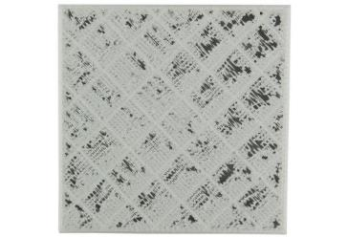A too thin top layer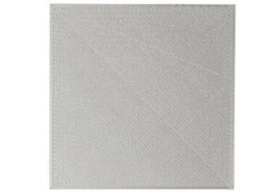A nicely closed top surface

**Cooling**

Besides good settings, it might be even more important to properly cool the plastic at the top surface. Make sure the print head fans are running at the maximum fan speed as set in the cooling settings in Cura. If they don’t, the plastic might not cool properly through which it may hang down a bit or curl up at the places where it crosses the infill lines. This means that an uneven surface is created for the next layer that must be placed on top of it, leading to bumps on the top surface. It seems that especially thinner layers have the tendency to curl up. Therefore, it could help to increase the layer height.

Lowering the printing temperature could also help, but ensure that your print doesn’t start under extruding. In this case it might be necessary to lower the print speed as well.

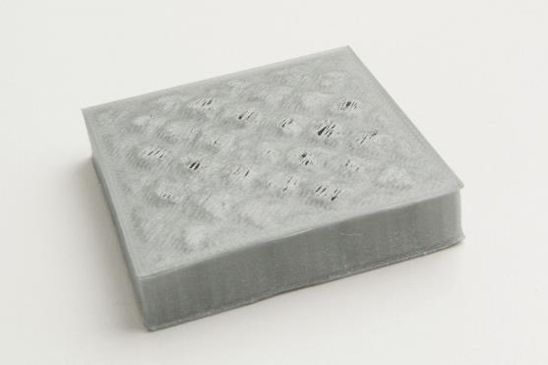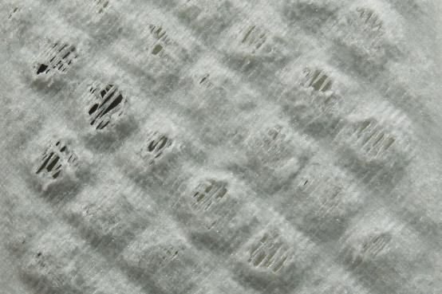The effect of no cooling on the top layer of your print

**How to fix stringing**

3D prints sometimes show small strands of plastic on places where the Ultimaker shouldn’t print and the print head must only travel from one place to another. These unwanted strands of plastic are called stringing. Stringing can be material dependent, but here we describe some general things you could do when dealing with stringing.

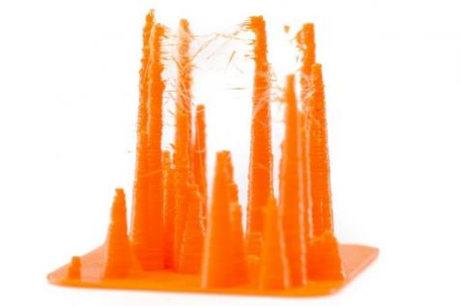**Retraction**

At the places in a print where the printer has to do a travel move between two printed parts and you don’t want it to leave plastic in between the use of retraction is important. This means that the filament is pulled back a little bit by the feeder, so that it doesn’t leak from the nozzle during the travel moves.

Retraction is a setting that can be found in Cura and is enabled by default. If you doubt about the retraction setting being on, it’s always wise to check it.

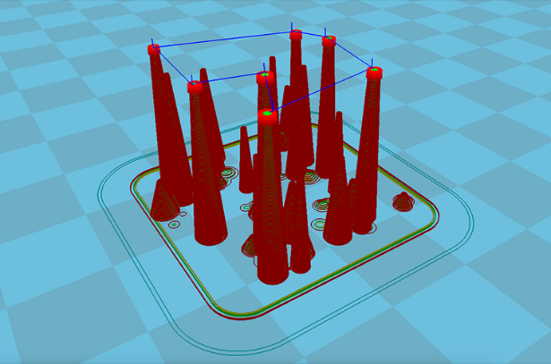 You should also be able to see this in the Layers view in Cura. Small dark blue vertical lines represent the retractions in the print. Although retraction may be turned on, there’s still a chance that small strands of plastic show up on places where you don’t it. Read on to find out what else you could do to decrease the amount of stringing.

The dark blue vertical lines are retraction moves

**Temperature**

To reduce the amount of stringing temperature is key. A high temperature means that the material will be more liquid, through which it can easily drip from the nozzle (even though retracted). By using a lower temperature, the material is less liquid and thus less likely to string.

It’s hard to say which temperature to use exactly, because this depends on the material (even colors can differ) and other print settings being used. But if you notice stringing on your print we would recommend lowering the temperature in steps of approximately 10 degrees to find out what the best setting for your material is. We figured out that for some prints in PLA we were even able to lower the temperature to 180 degrees. With a higher temperature the material will string more

**Speed**

While lowering the temperature is one thing, the print speed also plays role. If you lowered the temperature there’s a chance that your material starts under extruding when still printing at a (too) high speed. Therefore, it’s recommended to reduce the print speed accordingly. This way you should for example be able to reach the low temperature of 180 degrees for PLA with a print speed of approximately 20 mm/s.

Furthermore, it could help to increase the travel speed. This way the print head will travel a bit faster, so that the material has less time to drip from the nozzle while traveling. A travel speed of 200 mm/s should be fine for most prints.

With the right settings you can minimize the amount of stringing

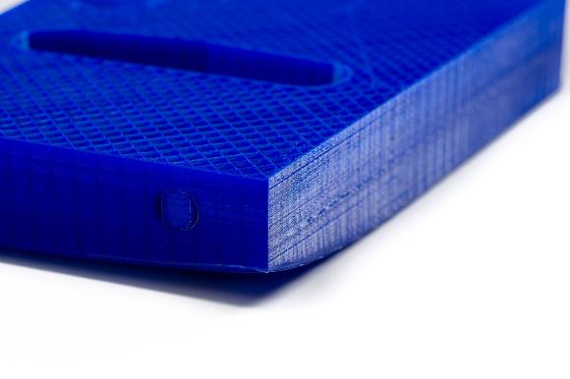**How to fix warping**

Warping occurs due to material shrinkage while 3D printing, which causes the corners of the print to lift and detach from the build plate. When plastics are printed, they firstly expand slightly but contract as they cool down. If material contracts too much, this causes the print to bend up from the build plate. Some materials shrink more than others (e.g. PC has a higher shrinkage than PLA), which means there’s a larger chance of warping when using it.

On this page, we will explain how to avoid or minimize print warping.

**Adhesion to the build plate**

To prevent warping, you need to ensure that the 3D print adheres well to the build plate. Without good adhesion, your print can become loose. This is particularly common at the corners. There are several ways to improve build plate adhesion, which are explained [here](https://ultimaker.com/en/resources/257-build-plate-adhesion-how-to-get-your-print-to-stick-to-the-build-plate).

**Use a heated build plate**

The best way to avoid warping is by using a heated build plate. This keeps the material at a temperature just below the point where it solidifies (the glass transition temperature), ensuring it stays flat and connected to the build plate. When you use a heated build plate it is important to use the right temperature. To find the right temperature for your material, please refer to our [material guides](https://ultimaker.com/en/resources/manuals/materials).

**Ensure the build plate is leveled correctly**

It is important that the first print layer of a print is pressed firmly onto the glass plate, to allow it to bond properly. If the distance between the nozzle and build plate is too wide, the material can easily become loose. If you are experiencing problems with the first print layer, we recommend re-leveling your build plate.

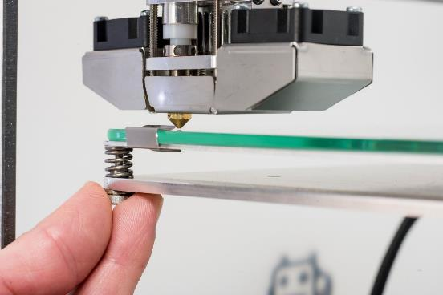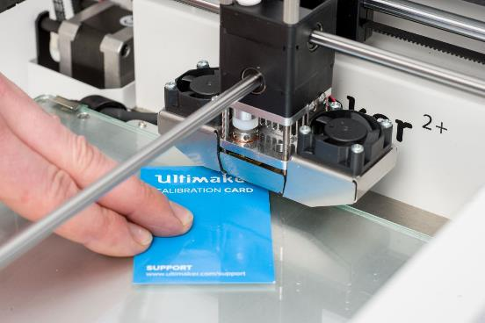

**Apply an adhesive**

To ensure that the print adheres well it is important that the print surface is smooth and clean. There should be no traces of oil or grease on it, as this will worsen the adhesion. When using a heated build plate, it’s recommended that you apply an adhesive to the glass plate. Adhesion methods differ per material – please refer to the [material manuals](https://ultimaker.com/en/resources/manuals/materials) for further information. Applying glue to the glass plate can help improving the adhesion

**Use a brim**

Cura has a built-in feature called a ‘brim,’ which is an effective way to stop your print from warping. This places a single-layer-thick, flat area around your object, which resists the pulling forces as the print cools. As the brim is only a single layer thick, it’s easy to remove once the print’s finished. Refer to the [Cura manual](https://ultimaker.com/en/resources/20423-platform-adhesion-cura) for further information.

**Use a raft**

For some materials or models, a brim might not be enough to prevent warping. In these instances, using a raft is advisable. A raft adds a thick grid between the model and the build plate, ensuring that the heat is distributed equally. It is particularly useful when the bottom of a model is not completely flat, or when printing with industrial materials. For more information about raft settings refer to the [Cura manual](https://ultimaker.com/en/resources/20423-platform-adhesion-cura).

**Adjust the initial layer settings**

Two important settings (relating to the first layer) that influence adhesion are the initial layer height and initial layer speed. In most cases, a thicker initial layer makes adhesion easier, as build plate calibration is not as critical. It is important not to set the initial layer speed too high, as the material may attach to the nozzle and get dragged around with it, instead of remaining fixed to the build plate.

**Cooling**

Cooling is one of the main causes of warping. Material contracts when cooling, and can cause the material to pull on itself. Materials need to be cooled properly before the next layer is added, but excessive cooling should be avoided to ensure a smooth, warp-free print.

**Use the fan settings properly**

The print head fans are usually turned off (fan speed = 0) for the first print layer, to ensure optimum build plate adhesion. Cura offers a range of fan settings to help avoid warping, such as ‘regular fan speed at height’ and ‘number of slower layers’. ‘Regular fan speed at height’ defines the height at which the fans will turn on, and ‘the number of slower layers’ sets the fan speed to increase gradually over a set amount of layers. To prevent warping, it’s advisable to leave the fans off for the first layer or to slowly increase the fan speed during the first few layers. This ensures that the bottom layer of the print maintains its temperature and avoids excessive cooling.

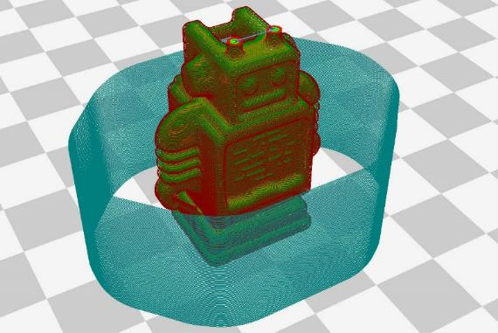**Print with a draft shield**

Cura offers the (experimental) option to print with a draft shield. This creates a one-layer thick wall around your model, preventing unwanted airflows from cooling it excessively.

**Use a front-side door**

Placing an enclosure around the model also protects it from airflow. Warmth is kept inside the printer, resulting in a more stable printing environment. When printing with industrial materials (e.g. PC and CPE+) an enclosure is strongly advised due to the high printing temperatures required.